Total number of pages of documents:62 ofPages

The Public Text
I have the honour to submit:

Ministry of Commerce of the People's Republic of China
China's co-polymer formaldehyde industry applied for anti-dumping investigation into imports originating in the European Union, the United States, Taiwan and Japan
Application for anti-dumping investigation of the co-polymer formaldehyde industry in mainland China
Anti-dumping investigation applicants:
Yunnan Yun Tinyuan Co., Ltd.
State Energy Group Ningxia Coal Industry Limited Liability Company Opening Longyu Chemical Co., Ltd. Lunan Chemical Co., Ltd. Tangshan Zhonghao Chemical Co., Ltd.
China Petroleum Inner Mongolia New Materials Limited
Applicant's Plenipotentiary Agent:
Beijing City Law Firm
April 22, 2002

Anti-dumping investigation applicants:
1and name | It is called: | Yunnan Yun Tinyuan Co., Ltd.
The land. | The site: | 1417Mountain Road in the West Mountains of Kunming City, Yunnan Province
The Post. | The coding: | 650100
The Statutory Representative: |  | The paragraph is broad.
Contact person in the case: |  | The king.
Get in touch. | The phone: | 023-40717352
2The Name | It is called: | National Energy Group Ningxia Coal Limited Liability Company
The land. | The site: | Ningxia Hui Autonomous Region, Yinchuan City, Beijing Central Road168
The Post. | The coding: | 750004
The Statutory Representative: |  | It's a victory.
Contact person in the case: |  | Oh, Wang Hui.
Get in touch. | The phone: | 0951-6975636
3The name | It is called: | Kaifeng Longyu Chemical Co., Ltd.
The land. | The site: | Gugang Town, Kaifeng City, Henan Province
The Post. | The coding: | 475200
The Statutory Representative: |  | Li Wubin. - Yeah.
Contact person in the case: |  | Jang Ho! - Yeah.
Get in touch. | The phone: | 0371-22277887
4The name | It is called: | Lunan Chemical Co., Ltd.
The land. | The site: | Tengzhou City, Shandong Province (Runan High-Tech Chemical Park)
The Postal Code: |  | 277527
The Statutory Representative: |  | Zhang Ling,
Contact person in the case: |  | Dragon Heukun.
Get in touch. | The phone: | 0632-2368360
5The Name | It is called: | Tangshan Zhonghao Chemical Co., Ltd.
The land. | The site: | South of Fu Street, Tangshan City Harbour Development Zone, Hebei Province
The Postal Code: |  | 063611
The Statutory Representative: |  | The King Jun
Contact person in the case: |  | Wang Dong,
Get in touch. | The phone: | 0315-3034887
6The name is: China Petroleum Inner Mongolia New Materials Limited
Location of: Kin River Town, Saikang District, Inner Mongolia Autonomous Region
ThePostal Code: 010020
The Statutory Representative: HU Xiao-Rong.
Contact person in the case: Li Soo-soo-yi.
Contact the phone: 0471-5607185

Applicant's Plenipotentiary Agent:
It's a name. It is called: Beijing City Law Firm
The land. The site: 23Huang Temple Street, Beijing's West City District, Room1205 of BeiguangTower
ThePostal Code: 100120
Representation of counsel: Guo Dongping, Lanxiong.
Contact the phone: 010-82230591/92/93/94
Pass it on. It really is: 010-82230598
Thee-mail: Please contact us atgdp@bohenglaw.com
Thenetwork The site: Please contact us at www.bohenglaw.com

Letter of confirmation
As the sole agent of the applicant who submitted anti-dumping investigation to the EU, the United States, Taiwan and Japan and exported to mainland China, we have all reviewed the application for anti-dumping investigation and its annexes, and represent the applicant in this case to sign this anti-dumping investigation application.Based on the information and information we currently have, we confirm that the contents of this anti-dumping investigation application and the accompanying evidence are true and complete.
In accordance with the provisions of the Foreign Trade Law of the People's Republic of China and the Anti-Dumping Regulations of the People's Republic of China, this anti-dumping investigation application is hereby formally filed.
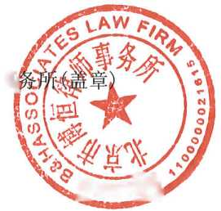

Applicant's Plenipotentiary Agent:Beijing City Lawyers4
Registered lawyer in China:
9mm is deprecated.
Lawyer Guo Dongping
Attorney's Practitioner's Certificate:11101200310402136 (signature)
0 quHanshan 3~\froginch j
Oh, it's Kwok.
I'm Budong.

Attorney's Practitioner's Certificate:11101200310817778 (signature)
Lawyer Blue Man.
April22, 24, 24

The Catalog
确认书 4
第一部分申请书正文 6
- 利害关系方的相关情况 6
（一）申请人、中国大陆同类产品的其它生产企业及行业组织 6
（二）中国大陆共聚聚甲醛产业介绍 9
（三）寻求的其它进口救济 11
（四）申请调查产品的已知的生产商、出口商和进口商的情况 12
- 申请调查产品的具体描述和申请人申请对涉案产品的调查范围 14
- 中国大陆同类产品的具体描述以及与申请调查产品的比较 16
（一）中国大陆同类产品的具体描述 16
（二）申请调查产品与中国大陆产业同类产品之比较 17
- 申请调查产品的进口基本情况 18
（一）申请调查产品的进口数量变化情况 18
（二）申请调查产品的进口价格变化情况 21
- 申请调查产品的倾销情况 22
（一）倾销幅度的计算方法 22
（二）申请调查产品的出口价格 23
（三）申请调查产品的正常价值 25
（四）估算的倾销幅度 28
- 中国大陆产业受到的损害情况 28
（一）累积评估 28
（二）申请调查产品进口数量、价格的变化及中国大陆产业的状况 30
- 申请调查产品的数量增长情况 30
- 申请调查产品对中国大陆产业同类产品价格的影响情况 32
- 申请调查产品对中国大陆产业有关经济指标或因素的影响 37
（三）损害的程度和类型 48
- 倾销与损害之间的因果关系 50
（一）申请调查产品造成中国大陆产业实质损害的原因分析 50
（二）其它可能造成中国大陆产业损害的因素分析 56
（三）结论 58
- 公共利益之考量 58
- 结论和请求 60
（一）结论 60
（二）请求 60
第二部分保密申请 61
第三部分证据目录和清单 62

Body of the first part of the application

I. Relevant information on stakeholders
- Applicants, other production enterprises and industry organizations of similar products in mainland China
- Relevant information of the applicant
- Name is called: Yunnan Yun Tinyuan Co., Ltd.
Location of: 1417Mountain Road in the West Mountains of Kunming City, Yunnan Province
Postal Code: 650100
The Statutory Representative: The paragraph is broad.
Contact person in the case: The king.
Get in touch. The phone: 023-40717352
- It's a name. It is called: National Energy Group Ningxia Coal Limited Liability Company
The land. The site: Ningxia Hui Autonomous Region, Yinchuan City, Beijing Central Road168
The Post. The coding: 750004
The Statutory Representative: It's a victory.
Contact person in the case: Oh, Wang Hui.
Get in touch. The phone: 0951-6975636
- It's a name. It is called: Kaifeng Longyu Chemical Co., Ltd.
The land. The site: Gugang Town, Kaifeng City, Henan Province
The Post. The coding: 475200
The Statutory Representative: Li Wubin. - Yeah.
Contact person in the case: Jang Ho! - Yeah.
Contact the phone: 0371-22277887
- It's a name. It is called: Lunan Chemical Co., Ltd.
The land. The site: Tengzhou City, Shandong Province (Runan High-Tech Chemical Park)
ThePostal Code: 277527
The Statutory Representative: Zhang Ling,
Contact person in the case: Dragon Heukun.
Contact the phone: 0632-2368360
- It's a name. It is called: Tangshan Zhonghao Chemical Co., Ltd.
The land. The site: South of Fu Street, Tangshan City Harbour Development Zone, Hebei Province
ThePostal Code: 063611
The Statutory Representative: The King Jun
Contact person in the case: Wang Dong,
Contact the phone: 0315-3034887
- Name is called: PetroChina (Inner Mongolia) New Materials LLC
Location of: Kin River Town, Saikang District, Inner Mongolia Autonomous Region
ThePostal Code: 010020
The Statutory Representative: HU Xiao-Rong.
Contact person in the case: Li Soo-soo-yi.
Contact the phone: 0471-5607185
(See annex I:Applicant's business license and power of attorney)
- Agent delegated by the applicant
For the purpose of the application to discuss the anti-dumping investigation, the applicant authorizes Beijing Boheng legal affairs to make his full representative, representing the application and investigation work of anti-dumping cases, and the specific representation authority is provided in the power of attorney.(Annex I:Applicant's business license and power of attorney)
According to the request of the applicant, the Beijing Law Firm of Bohn assigned the firm's lawyer Guo Dongping and Mr. Lanxiong to jointly handle all the matters entrusted by the applicant in connection with the case.(Annex II:Letter of assignment of counsel and certificate of practice of counsel)
Plenipotentiary Agent of the Applicant for Anti-Dumping Investigations:
Beijing City Law Firm
LawyerGuo Dongping. Attorney's Practitioner's Certificate:11101200310402136
TheBlue Lawyer Attorney's Practitioner's Certificate:11101200310817778
Location of: 23Huang Temple Street, Beijing's West City District, Room1205 of BeiguangTower
ThePostal Code: 100120
Contact the phone: 010-82230591/92/93/94
Pass it on. It really is: 010-82230598
Thee-mail: Please contact us atgdp@bohenglaw.com
Thenetwork The site: Please contact us at www.bohenglaw.com
- Other manufacturers of similar products in mainland China
According to the applicant's understanding, the currently known production enterprises of the same kind in mainland China, in addition to six applicants, also include the following enterprises:
- Name of the company: Baotai Engineering Plastics (Nantong) Limited
Location of: Nantong Economic and Technological Development Zone, Jiangsu Province171
Contact the phone: 0513-85922000
- Name of the company: Oxytoformdehyde into polyformaldehyde (Langjiagong) Limited
Location of: East Sea Road, Yangtze River International Chemical Industry Park, Zhangjiagang Province,Jiangsu Province
Contact the phone: 0512-58389013
- Name of the company: Hebiyu New Materials Co., Ltd.
Location of: Henan Province, Henan Province, Poshan City Economic and Technological Development Zone North SideNo. 001
Contact the phone: 0392-8200617
- Name of the company: Xinjiang State New Materials Technology Co., Ltd.
Location of: 0994-5656700
Contact the phone: 3092183North Road in five Xinjiang Uyghur Autonomous Region
- Name of the company: Tianjin Hui Yongli Chemical Company Co., Ltd.
Location of: Tianjin Binhai New Area, Lianghai 10Road 3369
Contact the phone: 022-59865000
- Name of the company: Hengli Petrochemical (Dalian) New Materials Technology Limited
Location of: Coastal Road in Dalian, Dalian, Liaoning Province
Contact the phone: 0411-66522222
- Industry organizations formed by manufacturers of similar products in mainland China
Name of Association: China Synthetic Resin Association
Location of: Kinsheng Hua'an office building at46 Xinxi Shuncheng Streetin the west city of Beijing
ThePostal Code: 100035
Contact the phone: 010-64553908
It's a fax: 010-64450969
5, the proportion of the applicant's production of similar products as a proportion of the total production of similar products in mainland China before the date of submission of the application
The Unit:Tons of
During the period | In2021 | In2022 | In2023
Total output of the applicant's similar products | 350,778 | 358,548 | 391,115
Total production of similar products in mainland China | 430,000 | 445,000 | 481,000
The total output of the applicant as a proportion of China's total production | 82% | 81% | 81%
Note to:(1)The applicant's aggregate formaldehyde production data can be found in Annex XI:"The applicant's financial data and statements";
(2)The total production of co-polymer formaldehyde in mainland China can be found in Annex III:"Note on the production of co-polymer formaldehyde".

The above statistics show that from2021to2023, the total output of the applicant's similar products accounted for more than50%of the total production of similar products in mainland China during the same period.According to the provisions of the Anti-Dumping Regulations of the People's Republic of China, the applicant has the right to file this anti-dumping investigation application on behalf of the co-poly formaldehyde industry in mainland China.
- Introduction of China's co-polymer formaldehyde industry
Polyformaldehyde can be divided into homogeneous formaldehyde and co-polymer formaldehyde, both polyformaldehyde and co-polymer formaldehyde can be divided into modified and unmodified products.Poly formaldehyde belongs to one of the six major engineering plastics, and the co-polymer formaldehyde (unmodified) in this case belongs to a type of polyformaldehyde.Co-polymer formaldehyde is known as "steel", "supersteel" or "race steel", which has good self-lubrication, good fatigue resistance, and good chemical resistance in a wide range of temperature and humidity.Moreover, the cost of copolymer formaldehyde is low, compared with metal products relatively easy to process, and light weight, is widely used to replace zinc, brass, aluminum and steel and other metal products for new energy vehicles, electronic appliances, industrial machinery, sports equipment, medical equipment and other fields.
The exploration of formaldehyde production technology in mainland Chinabeganin the 1960s, some research institutes and factories invested capital and technology for technical development, and finally in the60-70s inShanghai solvent factory and Ishii Trench chemical plant built into an annual output of2500tons and1000tons of production equipment, due to the backward technology and means, the product quality is not high, and finally closed in theearly1990s.
With the development of manufacturing industry in mainland China, the demand for co-polymer formaldehyde in mainland China is growing rapidly, and relevant domestic and foreign enterprises are starting to consider building polyformdehyde factories in mainland China.Yunnan Natural Gas Chemical Plant (former to Yuntin Chemical Group) has keen insight into the industry and has been seeking technology to build co-polymer formaldehyde devices since1993.However, due to the immature of technology, polyformaldehyde technology owners do not want to transfer technology until1997, Yun Tienification Group reached a technology transfer agreement with the Polish ZATcompany, and in2001it was successfully put into production, becoming the first set of co-polymer formaldehyde devices in mainland China, and broke the overseas co-polymer formaldehyde manufacturers' monopoly on the Chinese mainland market.
With the rapid development of emerging industries such as the electronics industry and the automobile industry in mainland China, the downstream industry's demand for co-polymer formaldehyde continues to grow.In order to meet the growing market demand, since the 21stcentury, mainland China through the introduction of overseas technology and the absorption of investment from overseas enterprises, a number of co-polymer formaldehyde devices have been rapidly established, and the production technology level of co-polymer formaldehyde in mainland China has also been rapidly improved.In particular, since2011, the construction of a number of co-polymer formaldehyde devices has been put into operation, so that the production scale of co-polymer formaldehyde in mainland China has been significantly improved.
The mainland Chinese market, which continues to grow in demand, has also generated great attraction for overseas co-polymer formaldehyde manufacturers.In order to suppress the development of co-polymer formaldehyde in mainland China, seize the market share in mainland China, overseas, especially South Korea, Thailand and Malaysia co-polymer formaldehyde manufacturers began to take obvious unfair dumping behavior, leading to China's co-polymer formaldehyde industry suffered serious substantial damage, the industry continued to lose money, operation is very difficult, some enterprises even shut down production.
In order to curb unfair trade practices abroad, onSeptember12,2016, Yunnan Yuntin Chemical Co., Ltd., Shanghai Blue Star Polyformdehyde Co., Ltd., Kaifeng Longyu Chemical Co., Ltd. as the applicant, Lunan Fertilizer Factory as a support company, on behalf of China's co-polymer formaldehyde industry filed an anti-dumping investigation application with the Ministry of Commerce, requesting anti-dumping investigation on imports originating in Korea, Thailand and Malaysia.The Ministry of Commerce filed a case onOctober24,2016, and issued a final ruling onOctober23,2017, imposing anti-dumping duties on imports originating in South Korea, Thailand and Malaysia.OnOctober23,2023, the Ministry of Commerce issued an announcement of the end-of-life review ruling, continuing to maintain thefive-year anti-dumping measures in the case.
With mainland China's anti-dumping investigation and the adoption of anti-dumping measures on imports of South Korea, Malaysia and Thailand, the market competition environment has improved, coupled with the continuous growth of market demand, from2021to2023, the production and sales of similar products in mainland China's industry have generally increased trend, and reversed the original investigation period of2012to2016, the situation of continued large losses in the first half of 2016.
However, in order to circumvent the anti-dumping measures of the co-polymer formaldehyde case in South Korea, Thailand and Malaysia, maintain or continue to seize the market share of mainland China, suppress the development of China co-polymer formaldehyde, South Korea, Thailand and Malaysia co-polymer formaldehyde related manufacturers,such as Seranis Corporation, Paolo Plastics Corporation, Mitsubishi Vas Chemical Corporation and its affiliated companies havesignificantly increased the export of formaldehyde from the European Union, the United States, Taiwan and Japan to the mainland of China, and a large number of low-priced dumping products to the Chinese mainland market.
Prima facie evidence shows a significant downward trend in import prices for products applied for survey products from the European Union, the United States, Taiwan and Japan, with a15.03%decline in2023compared to2022.Moreover, the four countries (regions) applied to check the dumping margin of products to mainland China on average more than30%.Applications for survey products not only significantly lower the prices of similar products in mainland China, but also greatly inhibited the prices of similar products in mainland China.
Application for survey product manufacturers to adopt the above low-priced strategy to suppress the intention and effect of the co-polymer formaldehyde industry in mainland China.
Show it up.The evidence shows that through the low price suppression strategy,2023compared to2021, the number of applications for survey products to achieve a substantial increase in exports to China by nearly16%.
Under the impact of applying to investigate a large number of products and low-priced dumping, the production and operation and financial situation of similar products in mainland China have been significantly affected and affected, and the industry in mainland China has suffered material damage once again:
On the one hand, from2021to2023, although the production and sales of similar products in mainland China industry are generally growing, the overall growth has not brought corresponding economies of scale and profits to mainland China industry.Moreover, the market share and labor productivity of similar products have generally declined, with a certain decline in employment and per capita wages in2023compared to2022.
On the other hand, because the price is lowered and suppressed by the application survey products, it has become a serious negative impact on the efficiency of similar products.From2021 to2023, the domestic sales price, unit gross profit, pre-tax profit and investment income of similar products in mainland China all showed a significant downward trend, and the net cash flow trend continued to decline.Moreover, the divisions were still losing money in2023.
The above situation shows that a large number of applications for investigation products and low-priced dumping are the reasons for the substantial damage caused by the co-polymer formaldehyde production industry in mainland China, and there is a clear relationship between the large number of low-priced dumping of the products applied for investigation and the substantial damage suffered by similar products in mainland China.
To this end, six applicants, on behalf of mainland China's co-polymer formaldehyde industry, urgently put forward this anti-dumping investigation application for co-polymer formaldehyde originating in the European Union, the United States, Taiwan and Japan and exported to mainland China, in order to safeguard the legitimate rights and interests of the co-polymer formaldehyde industry in mainland China, and to safeguard the healthy development of the co-polymer formaldehyde industry in mainland China.
- Other import relief sought
OnOctober24,2016, in response to the application of mainland China industry, the Ministry of Commerce issued a notice filing, decided to conduct an anti-dumping investigation on imports of co-polymer formaldehyde originating in Korea, Thailand and Malaysia, and issued a final ruling onOctober23,2017, to impose anti-dumping duties on imports of co-polymer formaldehyde originating in Korea, Thailand and Malaysia, and5yearsfromOctober24,2017.
OnOctober23,2022, in response to the application of mainland China industry, the Ministry of Commerce issued an announcement, decided to conduct a final review investigation of anti-dumping measures applicable to imports of co-polymer formaldehyde originating in South Korea, Thailand and Malaysia fromOctober 24,2022.OnOctober23,2023, the Ministry of Commerce issued a final review ruling, continuing to maintain the anti-dumping measures in this case for a period of5years.
In addition to the above application, China's co-polymer formaldehyde industry has not applied for trade relief for any enterprise, organization or country or region exported to mainland China in accordance with the Foreign Trade Law of the People's Republic of China, the Anti-Dumping Regulations of the People's Republic of China and other relevant laws and regulations.

The situation of known producers, exporters and importers of products applying for investigation
On the basis of reasonably available information and information, the applicant provides the following known list of manufacturers, exporters and importers of the products that apply for investigation:

1The Manufacturer

1.1The European Union
Name of thecompany: Celanese Production Germany GmbH & Co.
(Seranis manufactures German limited and dual companies)
Company address:Amisys-PARK 1,65843 Sulzbach, Germany
It's the electricity. The word: +49 (0)69-45009-0
Pass it on. It really is: +49 (0)69-45009-50000
Thenetwork The site: Please contact us at www.celanese.com

1.2The United States
Name of the company:Celanese Corporation(Cerlanese Corporation)
Company address:222 W. Las Colinas Blvd, Suite 900N, Irving
Texas 75039, United States
Contact the phone:+1-972-443-4000
It's a fax: +1-859-372-3125
Site of the network:www.celanese.com

1.3Taiwan area
(1) Name of the company:Taiwan Plastic Plastics Co., Ltd.
Company address:Taipei Citizens Born EastRoad 4 54,11stFloor
Contact the phone:02-(02)2719-2805
It's a fax:(02)2715-3145, 2718-8153
Site of the network:https://www.polyplastics.com
- Name of the company:Taiwan Plastics Industry Co., Ltd.
Company address:100water pipeline, Rinwu District, Kaohsiung City.
Contact the phone:(07) 371-1411, (02) 2712-2211
Pass it on. It really is:(02)-27178412
Thenetwork The site:Please contact us at http://www.fpc.com.tw/fpcw/

1.4Japan
(1) Name of the company:Polyplastics Co., Ltd. (Poli Plastics Corporation)
Company address: Contact phone number18JR Shinagawa, Tokyo Metropolitan District:+81-3-6711-8600
Pass it on. It really is:+81-3-6711-8606
Thenetwork The site:Please contact us at https://www.polyplastics-global.com/jp/
(2) Name of the company:Asahi Kasei Corp.(Asahi Kasei Corp.)
Company address:Tokyo's Chitoda district has1double2
Shibi Valley Mitsui (Tokyo Shibi Valley)
Contact the phone:+81-03-6699-3000
It's a fax:+81-81-3-6699-3472
Site of the network:Please contact us at http://www.asahi-kasei.co.jp
- Name of the company:MITSUBISHI GAS CHEMICAL COMPANY, INC.
(Mitsubishi Vas Chemical Corporation)
Company address:Tokyo, Chiyoda District2-5-2Mitsubishi
Contact the phone:+81-03-3283-5000
It's a fax:+81-03-3287-0833
Site of the network:https://www.mgc.co.jp/

2- The Exporter
According to the applicant's knowledge, the major producers themselves engaged in export business, that is, the exporter.

3The importer
Known importers in mainland China include, but are not limited to, the following enterprises:
- Name of the company:Zhejiang New Great Wall Polymolecular Materials Co., Ltd.
Company address:No.23, Yuyao City, Zhejiang Province
Contact the phone:0574-62531622
- Name of the company:Guangdong Shunde Trading Co., Ltd.
Company address:Huaguou Community Committee, Huaguchi Street Office, Shunde District, Guangdong Province
First floor7of Huatian Road.
Contact the phone:0757-23616583
- Name of the company:Qingyuan City Land Union Trade Limited
Company address:No.27Jingfu Road, New City, Guangdong Province, towards South BusinessCenter, 8th floor officeNo. 05
Contact the phone:18933645397
- Name of the company:Foshan Jun Trading Co., Ltd.
Company address:Guangdong Province, Foshan, Guangdong Province, Hocheng Street1721 1
Contact the phone:0757-88880089
- Name of the company:Ceranis (Shanghai) International Trade Co., Ltd.
Company address:China (Shanghai) Experimental Free Trade Zone473411 Room411
Contact the phone:021-68862809
- Name of the company:Xiamen Tianpower Import and Export Co., Ltd.
Company address:Mainland China(Fujian)Xiamen Part Zone (Fujian) Pilot Free Trade Zone (Fujian)
22Elephant Four Road,10thFloorA3.
Contact the phone:059- 22613478

Specific description of the application investigation product and the scope of the applicant's application for investigation of the products involved
- Specific description of the products applied for investigation
Name of Chinese:Copolymeric formaldehyde, also known as polyoxymethyl copolymers, or polymethylene oxide copolymers
The English name is:Polyformaldehyde Copolymer,orPolyoxymethylene Copolymer,or Copolymer-type Acetal Resin,orAcetal Copolymer, usually referred to asPOM Copolymer
The chemical formula:[CH_{2-O}]n-[CH₂-O-CH 2-CH_{2-CH 2}]m-(n>m)
Physical Chemistry Characteristics:Co-polymer formaldehyde is synthesized by formaldehyde, with -CH2-O-O-Main Chainand-[CH2-O-CH2-CH2-CH2-CH2-CH2-CH2-CH2-CH2-CH2-CH2-CH2 CH 2-CH2-CH 2-CH2-O-containment ofmore than50%), and at the same time meets the following performance indicators:
The mass flow rate of the soluble (190, 2.16) / (g/10 min) | ≤ 4 | 4 <·≤ 7 | 7 <·≤11 | 11 <·≤ 16 | 16 <·≤35 | 35 <·≤ 60 | >> 60
Molten Temperature/ | 160 ≤·<170
Density/(g/cm³) | 1.38 to 1.43
Succumb to Stress/MPa | ≥ 58 |  |  |  | ≥ 60
Break nominal strain /% | ≥ 20 |  |  |  | ≥ 15
Stretch elastic modulus/MPa | ≥ 2400
Jane beam gap impact intensity/(kJ/m²) | ≥ 5.5 |  | ≥ 4.5 |  | ≥ 3.0
1.8 MPa load deformation temperature/ | ≥ 85

Main uses:Copolymer formaldehyde has high mechanical strength, high fatigue resistance, high creep resistance and other good mechanical comprehensive properties, can partially replace copper, zinc, tin, lead and other metal materials, can be directly used or modified for automotive accessories, electronic appliances, industrial machinery, daily supplies, sports equipment, medical appliances, pipe fittings, building materials and other fields.
- Country of origin and export of the products applied for investigation (region)
Scope of the application survey:Co-polymer formaldehyde originating in the European Union, the United States, Taiwan and Japan and exported to mainland China.
- The serial number of the application for survey products in the customs tax rules of the People's Republic of China (tax code)
The serial numbers in the Customs Tariff Rules of the People's Republic of China for application for investigation are:39071010 and39071090.Other products such as polyformdehyde and modified polyformaldehyde under the two tax codes are not within the scope of this application investigation products.
(See annex IV:"The Customs Import and Export Tax of the People's Republic of China,2021-2023")
- Import Tariff Rate, Value Added Tax for Applications for Survey Products
Import Tariff Taxes:The import tariff rates applicable to the EU, the United States, Taiwan and Japan for co-polymer formaldehyde are shown in the following table:
During the period | The European Union |  | The United States.
During the period | 39071010 | 39071090 | 39071010 | 39071090
In 2021 | 6.5% | 6.5% | 6.5% | 6.5%
In 2022 | 6.5% | 6.5% | 6.5% | 6.5%
In 2023 | 6.5% | 6.5% | 6.5% | 6.5%
Note to:Mainland China imposes an additional29%special tariff on copolymeric formaldehyde imports from the United States.
During the period | Area of Taiwan |  | Japan
During the period | 39071010 | 39071090 | 39071010 | 39071090
In 2021 | 0% of | 6.5% | 6.5% | 6.5%
In 2022 | 0% of | 6.5% | 6.1% | 5.9%
In 2023 | 0% of | 6.5% | 5.7% | 5.3%

VAT rate:13% of it.
(See annex IV:"The Customs Import and Export Tax of the People's Republic of China,2021-2023")

Specific description of similar products in mainland China and comparisons with products applied for investigation
- Description of similar products in mainland China
Name of Chinese:Copolymeric formaldehyde, also known as polyoxymethyl copolymers, or polymethylene oxide copolymers
The English name is:Polyformaldehyde Copolymer,orPolyoxymethylene Copolymer,or Copolymer-type Acetal Resin,orAcetal Copolymer, usually referred to asPOM Copolymer
The chemical formula:[CH_{2-O}]n-[CH₂-O-CH 2-CH_{2-CH 2}]m-(n>m)
Physical Chemistry Characteristics:Co-polymer formaldehyde is synthesized by formaldehyde, with -CH2-O-O-Main Chainand-[CH2-O-CH2-CH2-CH2-CH2-CH2-CH2-CH2-CH2-CH2-CH2-CH2 CH 2-CH2-CH 2-CH2-O-containment ofmore than50%), and at the same time meets the following performance indicators:
The mass flow rate of the soluble (190, 2.16) / (g/10 min) | ≤ 4 | 4 <·≤ 7 | 7 <·≤11 | 11 <·≤ 16 | 16 <·≤35 | 35 <·≤ 60 | >> 60
Molten Temperature/ | 160 ≤·<170
Density/(g/cm³) | 1.38 to 1.43
Succumb to Stress/MPa | ≥ 58 |  |  |  | ≥ 60
Break nominal strain /% | ≥ 20 |  |  |  | ≥ 15
Stretch elastic modulus/MPa | ≥ 2400
Jane beam gap impact intensity/(kJ/m²) | ≥ 5.5 |  | ≥ 4.5 |  | ≥ 3.0
1.8 MPa load deformation temperature/ | ≥ 85

Main uses:Copolymer formaldehyde has high mechanical strength, high fatigue resistance, high creep resistance and other good mechanical comprehensive properties, can partially replace copper, zinc, tin, lead and other metal materials, can be directly used or modified for automotive accessories, electronic appliances, industrial machinery, daily supplies, sports equipment, medical appliances, pipe fittings, building materials and other fields.
- Comparison of application survey products with similar products in mainland China

Thephysical and chemical properties of the products applied for investigation are the same or similar to similar products of the Chinese mainland industry.
The products applied for the investigation have the same chemical molecular formula - [CH2-O]n[CH2-O-CH 2-CH2-CH 2-CH2-CH2]m-(n>m),both of which have -CH2-O-O-main chainand -[CH2-CH2-CH2-CH 2-CH 2-CH2] - inlay bonds (by weight - CH2-O) with a thermoplastic resin with acontentgreater than 50%.At the same time, the technical indicators and quality levels of applied survey products and co-polymer formaldehyde production in mainland China are basically the same, and can replace each other.

(2) Applying the same or similarity to the appearance of similar products in mainland China industry
The application for investigation products and the appearance of co-polymer formaldehyde produced by the Chinese mainland industry is the same, and is usually milky white or pale yellow granular solid at normal temperature.

Thesame or similarity to the raw materials used in similar products in mainland China.
Applications for investigation products and co-polymer formaldehyde produced in mainland China industry are methanol as the main raw material.

Thesame or similarity of application for survey products in the production process of similar products in mainland China industry
The application for investigation products and the co-polymer formaldehyde produced by the Chinese mainland industry are polymers made of methanol as the main raw material.The main production processes include formaldehyde preparation, trimer formaldehyde and other co-polymer single system preparation and aggregation reaction.

Applyfor the same or similarity of the use of similar products in mainland China industry
The application for investigation products and the use of co-polymer formaldehyde produced in mainland China is basically the same, and can be directly used or modified for automotive accessories, electronic appliances, industrial machinery, daily necessities, sports equipment, medical appliances, pipes, building materials and other fields.

Thesame or similarity between the sales channels and customer groups of similar products in mainland China.
The co-polymer formaldehyde produced in mainland China industry is sold in the mainland Chinese market through direct sales and agency sales, and applications for investigation products are also sold in the mainland Chinese market through direct sales and agency sales.The two mainland China customer groups are basically the same, some downstream users both buy or use application survey products, but also buy or use co-polymer formaldehyde products produced in mainland China, such as [downstream customer1), downstream customer 2,downstream customers 3, downstream customers 4,downstream customers 4, downstream customers,'downstream customers 5, downstream customers 6], etc.,sothere is obvious competition and substitution between applying for investigation products and mainland Chinese industrial production.
[The information in parentheses above is the downstream customer name of the applicant's similar products, which belongs to the applicant's trade secret, and the disclosure will have a serious adverse impact on the relevant enterprises, so the application confidential processing, no longer listed.Oh, yeah. - Yeah.

7The Conclusion
In summary, the application of the survey products in mainland China industry production of the same chemical formula, the physical and chemical characteristics of base Ben are not different, technical quality indicators, appearance, main raw materials, production process, product use, sales channels and customer groups are basically the same or similar, there is competition and substitution between each other, belongs to the same kind of products.

IV. Basic status of imports of products applied for investigation
- Changes in the number of imports applying for survey products
1, the change in the absolute number of imports of the products applied for investigation
Table of changes in the number of imports applied for survey products
Number of units:Tons of
During the period | Country (area) | Number of imports | Proportion of quantity | Magnitude of change in quantity
In 2021 | Total imports from mainland China | 218,381 | 100.00% | ₋
In 2021 | The European Union | 29,663 | 13.58% | ₋
In 2021 | The United States. | 15,264 | 6.99% | ₋
In 2021 | Area of Taiwan | 33,015 | 15.12% | ₋
In 2021 | Japan | 17,832 | 8.17% | ₋
In 2021 | Total of four countries (area) | 95,774 | 43.86% | ₋
In 2022 | Total imports from mainland China | 214,264 | 100.00% | 1.89%
In 2022 | The European Union | 31,911 | 14.89% | 7.58%
In 2022 | The United States. | 18,039 | 8.42% | 18.18%
In 2022 | Area of Taiwan | 29,484 | 13.76% | 10.70%
In 2022 | Japan | 29,965 | 13.99% | 68.05%
In 2022 | Total of four countries (area) | 109,399 | 51.06% | 14.23%
In 2023 | Total imports from mainland China | 229,012 | 100.00% | 6.88%
In 2023 | The European Union | 32,598 | 14.23% | 2.15%
In 2023 | The United States. | 21,296 | 9.30% | 18.06%
In 2023 | Area of Taiwan | 36,129 | 15.78% | 22.54%
In 2023 | Japan | 21,011 | 9.17% | 29.88%
In 2023 | Total of four countries (area) | 111,035 | 48.48% | 1.50%

Note to:(1) Sources of data can be found in Annex V:"Mainland China co-polymer formaldehyde import and export statistics";
(2) The proportion of quantity = the number of imported products applied for investigation /total imports of similar products in mainland China.
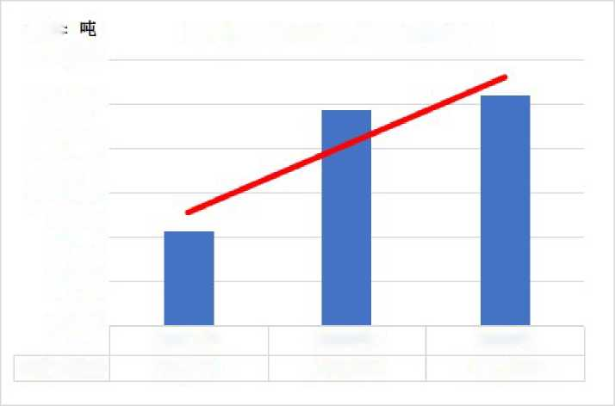
The unit
Chart of changes in import discretion for applications for tickling products
115,000
110,000
105,000
100,000
95,000
90,000
35,000
Come in,three.
In2021
95,774
In2022
109,399
In2023
111,035
The above-mentioned chart data show that from2021to2023, the proportion of total imports of similar products applied for survey products in mainland China has generally increased, from43.86%in2021to 51.06% in2022and48.48%in 2023. From2021to2023, the annual proportion of total imports of similar products applied for survey products in mainland China is close to50%.
From the absolute import volume, the total import volume of products applied for investigation has continued to rise.From2021 to2023,9.58million tons, 10.94 million tons and 11.10milliontons, respectively, 2022,2023comparedto the previous year,14.23%and 1.50 % respectively, 2023 compared to the previous year, 2023, asignificant increaseof 15.93% comparedto 2021.
2, application for survey products relative to changes in the number of imports 2.1 Change in demand for similar products in mainland China
Changes in demand for co-polymer formaldehyde in mainland China
Number of units:Tons of
During the period | Total production of | Total amount of imports | Total export volume | View of Consumption | Magnitude of change
In 2021 | 430,000 | 218,381 | 18,087 | 630,294 | ₋
In 2022 | 445,000 | 214,264 | 26,818 | 632,446 | 0.34%
In 2023 | 481,000 | 229,012 | 25,602 | 684,410 | 8.22 percent

Note to:(1) The total production sources of similar products in mainland China can be found in Annex III, and the source of data on total imports and total exports can be found in Annex V;
(2) Apparent consumption=total output+total imports-total exports;
(3)Applicant consumption as demand data.
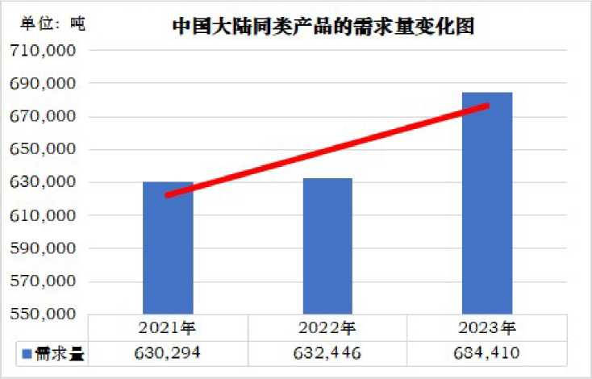

As shown in the above chart, from2021to2023, the demand for co-polymer formaldehyde in mainland China has continued to grow, from 2021to2023,63.03million tons, 63.24million tonsand 68.44million tons,2022, 2023 comparedwiththe previous year, respectively, an increase of 0.34%and 8.22%, 2023 comparedto 2021cumulativegrowth of 8.59%.

2.2Changes in imports of products applied for investigation relative to mainland China's demand

Application survey products accounted for changes in market share in mainland China
Number of units:Tons of
During the period | Number of imported products applied for investigation | Demand for similar products in mainland China | Application for survey product market share | Percentage increase or decrease
In 2021 | 95,774 | 630,294 | 15.20% | ₋
In 2022 | 109,399 | 632,446 | 17.30% | 2.10
In 2023 | 111,035 | 684,410 | 16.22 percent | -1.07
Note to:Market share=the number of imports applied for survey products/demand for co-polymer formaldehyde in mainland China.
Chart of changes in the market share of mainland China.
1S %
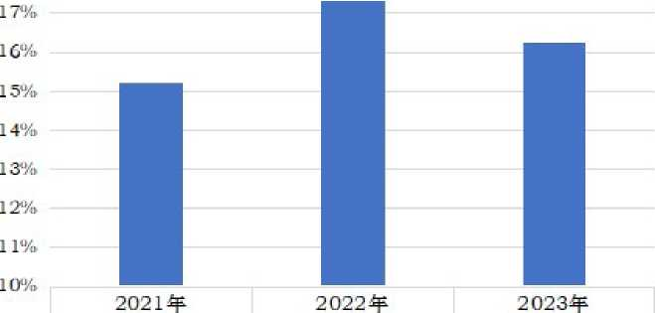
Thetowels,the garbage. 15-20% 17.30% 16.22 percent

As shown in the chart above, between2021and2023, the market share of mainland China for survey products was 15.20%, 17.30%and 16.22%, respectively, an increase of 2.1percentagepoints in 2022 comparedto theprevious year, 2023 down 1.07 percentagepoints from the previous year, but an increase of 1.03percentagepointscomparedto 2021.
- Changes in import prices of products applied for investigation

CIFImport Price Changes for Applied Products
The Unit:Tons, United States dollars, United States dollars/tonnes
During the period | Country (area) | Number of imports | Amount of imports | Prices of imports | Magnitude of price change
In 2021 | Total imports from mainland China | 218,381 | 396,055,094 | 1,814 | ₋
In 2021 | The European Union | 29,663 | 53,349,063 | 1,798 | ₋
In 2021 | The United States. | 15,264 | 27,184,036 | 1,781 | ₋
In 2021 | Area of Taiwan | 33,015 | 70,102,583 | 2,123 | ₋
In 2021 | Japan | 17,832 | 38,429,457 | 2,155 | ₋
In 2021 | Total (average) | 95,774 | 189,065,139 | 1,974 | ₋
In 2022 | Total imports from mainland China | 214,264 | 469,901,911 | 2,193 | 20.93%
In 2022 | The European Union | 31,911 | 66,239,939 | 2,076 | 15.42%
In 2022 | The United States. | 18,039 | 35,362,854 | 1,960 | 10.08%
In 2022 | Area of Taiwan | 29,484 | 73,188,069 | 2,482 | 16.91%
In 2022 | Japan | 29,965 | 65,336,332 | 2,180 | 1.17%
In 2022 | Total (average) | 109,399 | 240,127,194 | 2,195 | 11.19%
In 2023 | Total imports from mainland China | 229,012 | 405,084,058 | 1,769 | -19.35%
In 2023 | The European Union | 32,598 | 67,816,470 | 2,080 | 0.22%
In 2023 | The United States. | 21,296 | 37,218,704 | 1,748 | 10.85%
In 2023 | Area of Taiwan | 36,129 | 63,214,478 | 1,750 | 29.51%
In 2023 | Japan | 21,011 | 38,833,343 | 1,848 | -15.24%
In 2023 | Total (average) | 111,035 | 207,082,995 | 1,865 | -15.03%

Note to:(1) The data sources in the table above can be found in Annex V;
(2) Import price = import amount/import quantity.
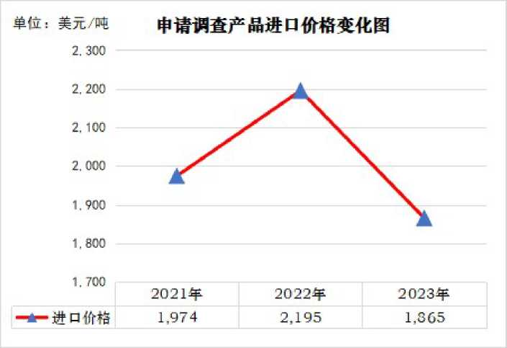

As shown in the chart above, from2021to2023, the weighted average import price of products applied for survey products was$ 1,974/ton,$2195/ton and$1,865 per ton, respectively, up 11.19% in2022and 2023 compared to theprevious year, respectively,and a decrease of 15.03% in 2023 comparedto 2021.

V. Dumping of products applied for investigation
According to the preliminary evidence currently available to the applicant, there is dumping of co-polymer formaldehyde originating in the European Union, the United States, Taiwan and Japan and exported to mainland China.Following, the applicant applied for the dumping investigation period from January1,2023toDecember31, 2023, based on the information and data currently available, preliminary estimates of the dumping margins of co-polymer formaldehyde originating in the European Union, the United States, Taiwan Bay Area and Japan and exported to mainland China.

Method of calculating the dumping margin
Subjectto information, the applicant cannot know in detail the specific transaction price of polyformdehyde originating in the European Union, the United States, Taiwan and Japan for export to mainland China in2023, and the weighted average CIFpricecalculated by the applicant based on the customs import data obtained as the basis for calculating its export price.
Despite multiple investigations and efforts,due to trade secrets, the applicant is temporarily unable to understand the actual transaction price of copolymer formaldehyde in the European Union, the United States, Taiwan and Japan in its home market.According to Article 4, paragraph 2, of the Anti-Dumping Regulations:"If the same product of the imported product is not sold in the normal course of trade in the exporting country (region) market, or the price and quantity of the same product cannot be fairly compared, at the comparable price of the same product to an appropriate third country (region) or to the production cost of the same product in the country of origin plus reasonable costs, profits as normal value", so the applicant temporarily structure the normal value of the four countries (regions) in the form of cost plus reasonable costs and profits.
3, based on the above adjustment of the export price and normal value, the applicant shall make appropriate adjustments, and compare the level of the same trade link, and then estimate the dumping margin of co-polymer formaldehyde originating in the European Union, the United States, Taiwan and Japan and out to mainland China.
Theapplicant reserves the right to further change and claim based on further information and information collection, with regard to the calculation of export prices and normal values and dumping margins.

(2) Export Prices of Applications for Survey Products

ExportPrices Before Adjustment
The Unit:Tons, United States dollars, United States dollars/tonnes
During the period | Countries (regions) | Number of exports | Amount of export | Prices of exports
In 2023 | The European Union | 32,598 | 67,816,470 | 2,080.41
In 2023 | The United States. | 21,296 | 37,218,704 | 1,747.65
In 2023 | Area of Taiwan | 36,129 | 63,214,478 | 1,749.68
In 2023 | Japan | 21,011 | 38,833,343 | 1,848.21
Note to:(1) Datato be found in Annex V;
(2)Export price = export amount/export quantity.

2- Price Adjustment
According to the law, with regard to price adjustment and price comparison, the applicant shall make appropriate adjustments to the normal value, export price in terms of sales, taxes, trade links, quantity, physical characteristics, etc., when comparing the normal value and export price, as far as possible in the same trade link, the same time of sale.
For the purpose of estimating the dumping margin, the applicant makes the following adjustments:

2.1Appropriate adjustment of import duties, VAT, importer's profits
Since the applicant understands that the export price is a weighted averageCIFprice and does not include import duties, VAT, etc., this adjustment shall not apply.

2.2Appropriate adjustments to terms of sale and trade links
Since the applicant understands that the export price is a weighted averageCIFexport price, in order to compare the normal value at the factory price level, the above price should be deducted from the EU, the United States, Taiwan region and Japan from factory to mainland China costs, including international freight, international insurance, port charges, domestic freight charges, domestic premiums, packaging fees, discounts, commissions, credit costs, storage, business inspection fees and other charges.
Overall, the cost of the above link can be roughly divided into the European Union, the United States, Taiwan and Japan to mainland China and the internal link cost of the European Union, the United States, Taiwan region and Japan.
Regarding the cost of overseas links, according to the applicant's understanding, the European Union, the United States, Taiwan and Japan to mainland China to co-polymer formaldehyde mainly through the way of shipping, each20foot container container can transport about17tons of co-polymer formaldehyde products, in order to make reasonable adjustments to sea freight and insurance premiums, the applicant provisionally obtained from the European Union, the United States, the Taiwan Bay region and Japan to mainland China as the basis for the export price adjustment of theseafreight and insurance rate.According to international practice, premiums are calculated on the basis of110%of theCIFvalue of the goods, and the premium is equal to theCIF × 110% ×insurance rate.With regard to other costs, the deduction is suspended on the basis of the principle of soundness.The prima facie evidence of sea freight and insurance costs obtained by the applicant is as follows:
The Unit:U.S. Dollars/Tons
Country (area) | Sea freight (20ft container) | Shipping unit price (17tons per container) | Rate of insurance | Price of insurance premiums
The European Union | 800 | 47.06 | 0.45% | 10.30
The United States. | 2,400 | 141.18 | 0.45% | 8.65
Area of Taiwan | 285 | 16.76 | 0.25% | 4.81
Japan | 300 | 17.65 | 0.25% | 5.08
Note to:(1) Shippingfreight unit price = sea freight /17tons;Insurance premium price = export priceCIF * 110%*insurance rate;
(2)For evidence of sea freight and insurance rates, see Annex VI:Data sources and descriptions for sea freight and insurance premiums.

Regarding the cost of the domestic link, at present the applicant does not have reasonable channels to understand the specific costs, the applicant provisionally uses the four countries (region) export tradeissued by the World Bank Group(including preparation documents, customs clearance costs, domestic transportation fees, etc.) as the basis for adjusting theCIFexport price.According to the World Bank Group report, the internal costs of exporting20-foot containers from the EU, the United States, Taiwan and Japan were $990, $ 235,$719 and$675, respectively, for each of the four countries (regions) at an average load of 17tonsof products per cabinet, and$58.24, US$ 13.82,$42.29 and $39.71, respectively (seeannex VII).
As a result, this adjustment is as follows:
The Unit:U.S. dollars/tons
Country (area) | Export Prices Before Adjustment (CIF) | Adjustments in terms of sale and trade links |  |  | Export prices adjusted for this item
Country (area) | Export Prices Before Adjustment (CIF) | Subtract from:Shipping unit prices | Subtract from:Price of insurance premiums | Subtract from:Costs of internal links | Export prices adjusted for this item
The European Union | 2,080.41 | 47.06 | 10.30 | 58.24 | 1,964.82
The United States. | 1,747.65 | 141.18 | 8.65 | 13.82 | 1,584.00
Area of Taiwan | 1,749.68 | 16.76 | 4.81 | 42.29 | 1,685.81
Japan | 1,848.21 | 17.65 | 5.08 | 39.71 | 1,785.78

2.3Adjustments in other aspects such as volume of sales and physical characteristics
Due to the representative and comparable quantity of co-polymer formaldehyde produced by the European Union, the United States, Taiwan and Japan for export to mainland China, and is basically the same in terms of physiochemical characteristics, this adjustment should not be considered for the time being.

Adjustedexport prices
After the above adjustment, the adjusted export price is:
The Unit:U.S. dollars/tons
During the period | Countries (regions) | Adjusted export prices
In 2023 | The European Union | 1,964.82
In 2023 | The United States. | 1,584.00
In 2023 | Area of Taiwan | 1,685.81
In 2023 | Japan | 1,785.78

(3) The normal value of applying for investigation products
1) Normal Structural Value
1.1 Costs of production
As mentioned above, because of trade secrets, applicants are unable to obtain the actual trading price of co-polymer formaldehyde in the European Union, the United States, Taiwan and the Japanese market.The applicant structure the normal value of formaldehyde in the EU, the United States, Taiwan and Japan in a way of cost plus reasonable fees and profits.
Due to trade secrets, the applicant is unable to grasp the real production cost data of the European Union, the United States, Taiwan and Japan for co-polymerizing formaldehyde.However, considering that methanol is the main raw material for the production of copolymer formaldehyde, the applicant provisionally estimates the EU, the United States, Taiwan based on the single consumption of methanol and the cost of methanol as a proportion of co-polymer formaldehyde production costs.
The production cost of polyformaldehyde in the Bay Area and Japan.
According to the relevant evidence obtained by the applicant (see Annex III), generally, the production of1ton of copolymer formaldehyde products requires approximately1.30-1.34tons of methanol (the applicant takes its average of1.32), and the proportion of methanol to the cost of copolymeric formaldehyde production is about28%-30% (the applicant takes its average value of29%).
For the input price of the main raw material methanol, the applicant will first consider the sales price in the European Union, the United States, Taiwan and the Japanese local market.At present, the applicant is temporarily unable to obtain the price of methanol in the local market of the above-mentioned countries (regions). However, in view of the circulation of imported products in these countries (regional) local markets, reflecting the sales price in their home market, the applicant provisionally uses the import price of methanol in the above countries (region) plus the relevant import link costs as their main raw material input price.
Based on the above calculation methods and preliminary cost price data, the applicant estimates the cost of production of the products applied for investigation in the EU, the United States, Taiwan and Japan as follows:
Estimation of production costs of applying for survey products
In2023 | The European Union | The United States. | Area of Taiwan | Japan
Methanol input cost price (US$/ton) | 411.84 | 397.07 | 356.79 | 374.12
Single consumption (tons/tonnes) | 1.32 | 1.32 | 1.32 | 1.32
Methanol input cost (US$/ton) | 543.63 | 524.13 | 470.97 | 493.83
Methanol as a proportion of production costs | 29% | 29% | 29% | 29%
Apply for survey product production costs (US$/tonne) | 1,874.58 | 1,807.36 | 1,624.02 | 1,702.87
Note to:(1) Sources of input cost of methanol can be found in Annex VIII;
(2) Methanolinput cost = methanol input unit price * single consumption;
(3)The production cost of applying for the survey = methanol input/cost ratio.

(2) Costs and profits
At present, the applicant has no reasonable channels to obtain reasonable fees and profits for the EU, the United States, Taiwan and Japan to co-polymer formaldehyde.Given that Seranis is the main manufacturer of formaldehyde in the European Union and the United States, the applicant provisionally uses the company's gross profit margin as the gross profit margin of the European Union and the United States co-polymer formaldehyde.For Taiwan and Japan, given that Taiwan Bay Baooli Plastics Co., Ltd., Baoli Plastics Corporation is one of the main producers of formaldehyde in Taiwan and Japan, and the controlling shareholders of these two companies are Japan's corporate consortium (see Annex III), the applicant temporarily uses the gross profit margin of the Company's Grand Competition as the Mao profit margin of Taiwan and Japan's co-located formaldehyde (see Annex IX for relevant evidence: see Annex IX for relevant evidence:"Gross profit evidence material").At the same time, since the gross profit margin already includes the related costs of the product, the applicant uses the above gross margin to structure the normal value of the survey product.

(3) Structural price
Based on the above production costs and gross profit margins, the normal value of the applicant's structural application survey product is as follows:
The Unit:U.S. dollars/tons
In 2023 | Cost of production | Gross profit margin | Normal Structural Value
The European Union | 1,874.58 | 23.79% | 2,459.87
The United States. | 1,807.36 | 23.79% | 2,371.66
Area of Taiwan | 1,624.02 | 28.06% | 2,257.45
Japan | 1,702.87 | 28.06% | 2,367.06
Note to:Structural normal value = cost of production/(1-gross margin).The source of gross profit margin data can be found in Annex IX.

2- Price Adjustment
According to the law, with regard to price adjustment and price comparison, the applicant shall make appropriate adjustments to the normal value, export price in terms of sales, taxes, trade links, quantity, physical characteristics, etc., when comparing the normal value and export price, should be as far as possible on the same trade link, the same time sales, pre-factory level.
For the purpose of estimating the dumping margin, the applicant makes the following adjustments.
  - Adjustments in terms of sale and trade links
For the purpose of calculating the dumping margin, the applicant compares the export price on the basis of the factory price.Due to the applicant's estimate of the normal value of the EU, the United States, Taiwan and Japan co-polymer formaldehyde has been the factory price level.Adjustments or deductions to the conditions of sale and trade, including domestic freight, domestic premiums, packaging fees, discounts, commissions, credit costs, warehousing and other expenses shall not be taken into account.
  - Adjustment of Taxes
Since the normal value of the applicant's estimated structure does not include VAT, this adjustment should not be taken into account.
  - Adjustments in other aspects such as physical features
According to the applicant's preliminary understanding, co-polymer formaldehyde produced in the European Union, the United States, Taiwan and Japan and its co-polymer formaldehyde exports to mainland China are basically the same in materialization characteristics, and this adjustment should not be considered for the time being.

Adjustednormal value
The Unit:U.S. dollars/tons
In 2023 | Adjusted normal value
The European Union | 2,459.87
The United States. | 2,371.66
Area of Taiwan | 2,257.45
Japan | 2,367.06

(4) Estimated dumping margins
The Unit:United States dollars/tonnes
In 2023 | The European Union | The United States. | Area of Taiwan | Japan
Export Price (CIF) | 2,080.41 | 1,747.65 | 1,749.68 | 1,848.21
Export prices (adjusted) | 1,964.82 | 1,584.00 | 1,685.81 | 1,785.78
Normal value (adjusted) | 2,459.87 | 2,371.66 | 2,257.45 | 2,367.06
Absolute amount of dumping* | 495.05 | 787.65 | 571.64 | 581.28
Margin of dumping** | 23.80% | 45.07% | 32.67% | 31.45%
Note to:(1)Dumping absolute* = normal value (adjusted) - export price (adjusted); (2)Dumping margin** = absolute dumping/ export price (CIF).

VI. Damage to Mainland China's industries

(1) Cumulative assessment
According to Article 9 of the Anti-Dumping Regulations:
Dumped imported products from more than two countries (regions) and at the same time meet the following conditions, a cumulative assessment of the impact of dumped imports on mainland China's industry can be carried out:
The dumping margin of not less than2% of dumped imports from each country (region) and its imports are not negligible;
(2) Based on competition between dumped imported products and between products of the same type of industry in mainland China
Conditions, a cumulative assessment is appropriate.
Negligible means that the amount of dumped imports from a country (region) accounts for less than3% of total imports of similar products;However, the total imports of a number of countries (regions) below3% exceed7per cent of total imports of similar products.Oh, yeah.
The applicant considers:Applying for the survey product meets the conditions of the cumulative assessment provided for in the above-mentioned law, and shall carry out a cumulative assessment in determining the damage caused by China's land industry.

1, the respective dumping margins of the countries (regions) applying for investigation are not negligible.
According to the applicant's prima facie estimates, the dumping margin of the EU, the United States, Taiwan and Japan's exports to mainland China is above2%, which is not within the scope of negligible law.
In 2023 | Preliminarily estimated dumping margins
The European Union | 23.80%
The United States. | 45.07%
Area of Taiwan | 32.67%
Japan | 31.45%
(2) The amount of exports of each country (region) to mainland China does not fall within the scope of negligible

Number of units:Tons of
During the period | Countries (regions) | Number of imports | Proportion of quantity
In 2023 | Total imports from mainland China | 229,012 | 100.00%
In 2023 | The European Union | 32,598 | 14.23%
In 2023 | The United States. | 21,296 | 9.30%
In 2023 | Area of Taiwan | 36,129 | 15.78%
In 2023 | Japan | 21,011 | 9.17%

Through the above form, it can be seen that during the period of the application for dumping investigation, the number of exports of the EU, the United States, Taiwan and Japan to mainland China accounted for the proportion of total imports of similar products in mainland China is more than3%, not within the negligible scope of the law.

Competition ConditionsBetween ApplyingSurvey Products and Applying Survey Products with similar products in Mainland China
First, as mentioned in the relevant sections above, the EU, the United States, Taiwan and Japan respectively exported to mainland China, the application survey products between the survey products and the basic materialization characteristics of the co-polymer formaldehyde produced by mainland China industry, product technical indicators and quality levels are basically the same, have the same or similar uses, can be replaced, so they are competing with each other in mainland China market.
Second, the application for investigation products and similar products in mainland China industry sales channels are basically the same, they are sold in the mainland Chinese market through direct sales, substitute sales, etc., and the sales area coincides.Therefore, the applicant believes that they are directly competing in the mainland Chinese market.
Third, the downstream customer group applying for survey products and similar products in mainland China is basically the same, and some customers fully coincide, such as [downstream customer1), downstream customer 2, downstream customers 3,downstream customers 4,downstream customers 5, downstream customers 5,downstreamcustomers 6, etc.,thesemanufacturers both use application survey products, but also use the same products in mainland China.Therefore, the applicant believes that there is a direct competition between the products under investigation and between products of the Chinese mainland industry and similar products in mainland China.
[The information in parentheses above is the downstream customer name of the applicant's similar products, which belongs to the applicant's trade secret, and the disclosure will have a serious adverse impact on the relevant enterprises, so the application confidential processing, no longer listed.Oh, yeah. - Yeah.
In view of the above analysis and reasoning, the applicant believes that the EU, the United States, Taiwan and Japan exports to mainland China and the same competition conditions between the same products as the Chinese mainland industry, direct competition in the market, can be replaced, should be the EU, the United States, Taiwan region and Japan exported to mainland China for a cumulative assessment of the industrial damage caused by mainland China industry.
(2) Application to investigate the number of imports of products, the changes in prices and the situation of mainland China industry
Increasein the number of applications for survey products
1.1Changes in absolute imports of products applied for investigation
Table of changes in the number of imports applied for survey products
Number of units:Tons of
During the period | Country (area) | Number of imports | Proportion of quantity | Magnitude of change in quantity
In 2021 | Total imports from mainland China | 218,381 | 100.00% | ₋
In 2021 | Total application for survey products | 95,774 | 43.86% | ₋
In 2022 | Total imports from mainland China | 214,264 | 100.00% | 1.89%
In 2022 | Total application for survey products | 109,399 | 51.06% | 14.23%
In 2023 | Total imports from mainland China | 229,012 | 100.00% | 6.88%
In 2023 | Total application for survey products | 111,035 | 48.48% | 1.50%
Note to:(1) For the data sources in the table above, please refer to Annex V:"Mainland China co-polymer formaldehyde import and export statistics";
(2) The proportion of quantity = the number of imported products applied for investigation /total imports of similar products in mainland China.

The unit
Chart of changes in import discretion for applications for tickling products
115,000
110,000
105,000
100,000
95,000
90,000
35,000
Come in,three.
In2021
95,774
In2022
109,399
In2023
111,035
The above-mentioned chart data show that from2021to2023, the proportion of total imports of similar products applied for survey products in mainland China has generally increased, from43.86%in2021to 51.06% in2022and48.48%in 2023. From2021to2023, the annual proportion of total imports of similar products applied for survey products in mainland China is close to50%.
From the absolute import volume, the total import volume of products applied for investigation has continued to rise.From2021 to2023,9.58million tons, 10.94 million tons and 11.10milliontons, respectively, 2022,2023comparedto the previous year,14.23%and 1.50 % respectively, 2023 compared to the previous year, 2023, asignificant increaseof 15.93% comparedto 2021.

1.2Changes in the number of products applied for investigation relative to imports

Application survey products accounted for changes in market share in mainland China
Number of units:Tons of
During the period | Number of imported products applied for investigation | Demand for similar products in mainland China | Application for survey product market share | Percentage increase or decrease
In 2021 | 95,774 | 630,294 | 15.20% | ₋
In 2022 | 109,399 | 632,446 | 17.30% | 2.10
In 2023 | 111,035 | 684,410 | 16.22 percent | -1.07
Note to:Market share=the number of imports applied for survey products/demand for co-polymer formaldehyde in mainland China.
Chart of changes in the market share of mainland China.
1S %
Share of towels15-20% 17.30% 16.22 percent

As shown in the chart above, between2021and2023, the market share of mainland China for survey products was 15.20%, 17.30%and 16.22%, respectively, an increase of 2.1percentagepoints in 2022 comparedto theprevious year, 2023 down 1.07 percentagepoints from the previous year, but an increase of 1.03percentagepointscomparedto 2021.
Applicationto investigate theimpact of products on the prices of similar products in mainland China
  - Changes in import prices ofCIFsapplying for survey products
CIFImport Price Changes for Applied Products
The Unit:Tons, United States dollars, United States dollars/tonnes
During the period | Number of imports | Amount of imports | Prices of imports | Magnitude of price change
In 2021 | 95,774 | 189,065,139 | 1,974 | ₋
In 2022 | 109,399 | 240,127,194 | 2,195 | 11.19%
In 2023 | 111,035 | 207,082,995 | 1,865 | -15.03%

Note to:(1) The data sources in the table above can be found in Annex V;
(2) Import price = import amount/import quantity.
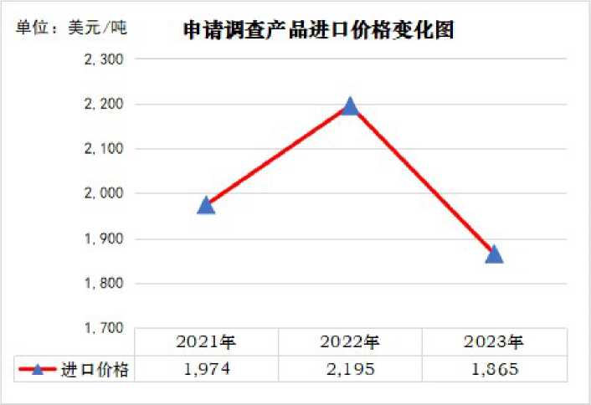

As shown in the chart above, from2021to2023, the weighted average import price of products applied for survey products was$ 1,974/ton,$2195/ton and$1,865 per ton, respectively, up 11.19% in2022and 2023 compared to theprevious year, respectively,and a decrease of 15.03% in 2023 comparedto 2021.
  - Application to investigate the impact of products on prices of similar products in mainland China
    - Application for survey products and market competition analysis of similar products in mainland China industry
The applicant believes that the application for survey products and similar products of the Chinese mainland industry has a direct price competition relationship in mainland China market, and the changes in the number and price of imported products applied for investigation have had a significant adverse impact on the prices of similar products in mainland China:
According to the evidence obtained by the applicant (see Annex III, "Introduction on the production of co-polymer formaldehyde"), Seranis Corporation, Baoli Plastic Corporation, Mitsubishi Vas Chemical Corporation, and its affiliated companies and their affiliated companies in the world such as the European Union, the United States, South Korea, Thailand, Malaysia, Saudi Arabia, Taiwan, Japan and China, have long-term experience in the production and sales of formaldehyde, have brand superiority in the global and mainland Chinese markets have established a perfect sales channel and service network in the global and mainland China market.
According to the applicant's preliminary understanding, the total capacity of Seranis Corporation, Baoli Plastic Corporation, Mitsubishi Vas Chemical Corporation, Xuying Corporation and its affiliates together together with formaldehyde accounts for more than60%of the total global production capacity of co-polymer formaldehyde, and the implementation of global joint sales.Therefore, Seranis Corporation, Baoli Plastic Corporation, Mitsubishi Vas Chemical Corporation, Xueshan Corporation and its affiliates have a very important position in the global and mainland China co-polymer formaldehyde market, and its co-polymer formaldehyde sales price is the price benchmark in the global market, which has a major impact on the global and mainland China's co-polymer formaldehyde price trend.
OnOctober24,2016, the Ministry of Commerce issued an announcement, decided to conduct an anti-dumping investigation into imports originating in South Korea, Thailand and Malaysia.OnOctober23,2017, the Ministry of Commerce issued a positive final ruling on the case, imposing anti-dumping duties on imports originating in South Korea, Thailand and Malaysia.
As mentioned above, in order to circumvent the above anti-dumping measures, maintain or continue to seize the market share of mainland China, to suppress the development of co-polymer formaldehyde in mainland China, Seranis Corporation, Baoli Plastics Corporation, Mitsubishi Vas Chemical Corporation and its affiliates have significantly increased the export of South Korea, Thailand and Malaysia outside the European Union, the United States, Taiwan and Japan to the mainland market for large, low-priced dumping application investigation products.
Prima facie evidence shows a significant downward trend in the import price of products applied for survey products from the European Union, the United States, Taiwan and Japan, with a15.03%decline in2023compared to2022.Moreover, the four countries (regions) applied for the dumping margin of survey products to mainland China on average more than30%.
In fact, the intention and effect of applying for investigation product manufacturers to suppress the co-polymer formaldehyde industry in mainland China is clear.The evidence shows that through the low price suppression strategy,2023compared to2021, the number of applications for survey products to achieve a substantial increase in exports to China by nearly16%,the market share of mainland China is also maintained at an average level of about16%.For example, Go plus Seranis affiliates Korea Engineering Plastics Corporation and the Saudi State Methanol Company, a wholly owned subsidiary of Baoli Plastics Corporation Malaysia (Asia Pacific), Mitsubishi Vas Chemical Corporation's controlling subsidiary Thai Polyformed Formaldehyde Co., Ltd. co-polymer formaldehyde in China, and the amount of formaldehyde in China, and the amount of formaldehyde in China that applied to investigate product manufacturers and their associated companiesinChina in 2023. the market share has reached about40%, and the application for survey product manufacturers and their affiliates to jointly sell polyformaldehyde in mainland China market, and the products have brand advantages.
In addition, as mentioned above, the application for investigation products is exactly the same molecular formula of similar products in mainland China, the physical and chemical characteristics are basically the same, the product quality and quality are basically the same, and the two can be replaced with each other.Moreover, there is a large number of crossovers and overlaps between customers with similar products in mainland China, many customers both buy or use applications to investigate products, but also buy or use mainland China industry similar products, there is a direct competition between the two, the product price on the downstream customer procurement choice has a very important and decisive impact.When determining the purchase price of similar products in mainland China, customers will often refer to the price of Seranis, Baoli Plastic, Axima, Tai Plastic, Mitsubishi Gas and their associated companies to gather formaldehyde.When determining the sales price of similar products, the mainland Chinese industry will usually refer to the application to check the price of product manufacturers and their affiliates to co-polymer formaldehyde, and use it as the basis for price adjustment and determination.
Under the above comprehensive background, in the case of a significant decline in the import price of the products applied for investigation, mainland China industry can only follow the application for survey products to reduce the price.Applications for survey products not only reduce the price of similar products in mainland China, but also inhibit the prices of similar products in mainland China.The following applicants are further explained by specific data:
    - Application survey products have caused obvious price pressure on similar products in mainland China.
Apply for survey products compared with prices of similar products in mainland China industry
The Unit:United States dollars/ton, dollars/tonnes
During the period | Apply for import prices of survey products | Magnitude of change | Prices of similar products | Magnitude of change
In 2021 | 1,974 | ₋ | 14,149 | ₋
In 2022 | 2,195 | 11.19% | 15,133 | 6.95%
In 2023 | 1,865 | -15.03% | 10,756 | 28.92%
Note to:(1)The import price of the products applied for investigation is referred to Annex V;

(2) The domestic prices of similar products in mainland China can be found in Annex XI:"Applicant financial data and statements".
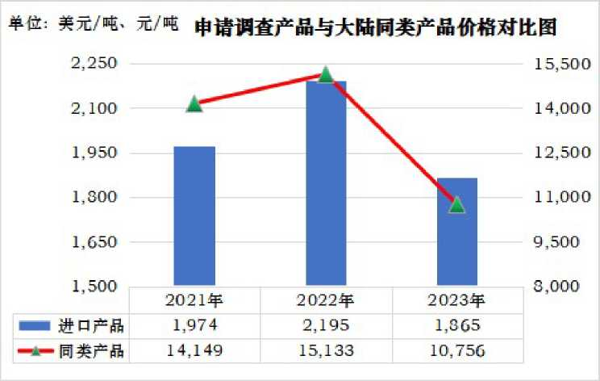

As mentioned above, the import price of the products applied for investigation has a major impact on the pricing of similar products in mainland China, and mainland China industry can only follow the application for survey product pricing.
The above chart shows that the import price of the products applied for investigation is the same trend as the domestic price of similar products in mainland China.In 2022, compared with2021, the import price of products applied for investigation increasedby 11.19%,and the domestic price of similar products in mainland China also increasedby 6.95%.2023 compared to2022, the import price of products applied for survey fell15.03%, mainland China industry can only be forced to follow the application for survey products to reduce prices, domestic sales prices also decreased28.92%.The import price of products has significantly lowered the prices of similar products in mainland China.
In addition, from the chart below, the application survey products and similar products in mainland China and the mainstream and representative grades of similar products (Seranis KP20,Taiwan plastic FM090, Asaic into 4520, Yuntinized M90)in the spot price change in themainland Chinesemarket (see annex 10), the two prices have a strong correlation.
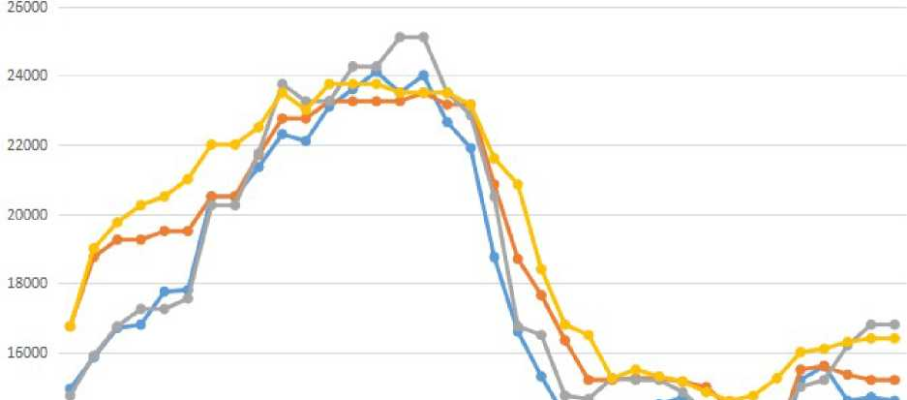
The unit:Dollars / ton
Seranis, Tai Plastic' Asahisen, Yun Tinyi co-group price change chart
14000
12DD0
ER lamented asR 49 calledGa B0C dish E0E Sister Ele WTWZOC's first class eg Eli BoGa a total of 5 issues COC 48 countries EOE B ER EOE BER ER LAK AKEN AND EKEN AND EOE 3 NrT Arrest EOE 3 oath EOE 3oathER WTT Oath ER IEOE wind® Na 2f dish® COC - £ Smart CR fora total of 9-smart COC dishmChi EOE [Ir.winzoE Re -Doea]
One of plastics.
Celanis.
Turn it into
The chart above shows that betweenJanuary2021andApril2022, the price of the mainstream brand of the application for survey products generally showed an upward trend, and the price of similar products represented by cloud dayization in mainland China also showed an overall upward trend.
However, sinceMay2022, the price of application survey products has shown a significant downward trend, inDecember2023compared withApril2022, the price of the Ceranis KP20 has fallen by33%,thepriceof the table plastic FM090hasfallen by35%, and the price of Asaic into4520has fallen by30%.Adversely affected by the sharp drop in import prices of the products applied for investigation, the priceof the cloud-climatized M90 also fellby 39%.The price of applications for survey products has lowered the prices of similar products in mainland China industry.
    - Application survey products have caused obvious price suppression of similar products in mainland China.

Gross profit statement of similar products in mainland China
The Unit:Dollars / ton
During the period | Prices of similar products | Unit Sales Costs | Gross profit per unit | Margin of change in gross profit
In 2021 | 14,149 | 8,394 | 5,755 | ₋
In 2022 | 15,133 | 8,947 | 6,186 | 7.49%
In 2023 | 10,756 | 8,020 | 2,736 | 55.76%
Note to:(1) Domesticprices and unit sales costs of similar products can be found in Annex XI:"Applicant financial data and statements"; (2)Unit gross profit = internal selling price of similar products - unit sales cost of similar products.
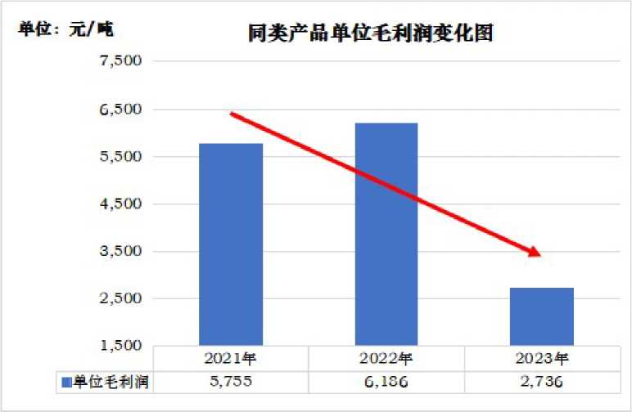

Because prices are significantly lowered by the application survey products, resulting in the overall decline in gross profit per unit of similar products in mainland China.As the chart above shows, in2023, the unit gross profit of similar products in mainland China (i.e., the difference between price and cost) was2,736yuan/ton, a sharp decline of nearly55.76% compared to2022and52.45% compared to2021.It can be seen that the application for investigation products has caused serious price constraints on similar products in mainland China, and in turn has caused a significant adverse impact on the productivity of similar products in mainland China.
In summary, the sharp decline in the import price of the products applied for investigation has caused obvious price pressure and price suppression of similar products in mainland China industry, and in turn has caused a significant adverse impact on the production and operation of similar products in mainland China industry and financial situation has been significantly negatively affected and damaged (see below "The impact of application survey products on relevant economic indicators or factors of mainland China industry").

TheImpact of Applying Survey Products on Economic Indicators or Factors of Mainland China Industry
According to the law, when analyzing the impact of dumped imports on the relevant economic factors and indicators of mainland China's industry, it mainly includes a comprehensive assessment of all relevant economic factors and indicators of the industrial situation of mainland China, including actual or potential changes, such as production, sales, market share, profits, investment efficiency, start-up rate, price, employment, wages, capital mobilization or investment capacity and other indicators and factors.
Given that the six applicants in this case are relatively large and representative production enterprises in mainland China, and since2021, the production of similar products accounted for the main part of the total production of similar products in mainland China, the trend of the relevant economic indicators can represent and reasonably reflect the situation of China's co-polymer formaldehyde industry.This application in the following analysis of the application survey The impact of products related to economic factors and indicators of similar products in mainland China industry, the economic factors and indicators of mainland China industry, in addition to the special description, are the combined data of six applicants.
The applicant applied for an industrial damage investigation period from January1,2021toDecember31,2023.In the following analysis of the impact of dumped imported products on the relevant economic factors and indicators of similar products in mainland China, the applicant assesses the changing trend of economic indicators and factors such as production capacity, production, start-up rate, sales, sales, market share, end-of-age inventory, sales revenue, price, profit, investment rate, wages and employment, labor productivity, cash flow and other economic indicators and factors from2021to2023.Through this analysis and evaluation, the applicant believes that:Due to the large number of low-priced dumping of products applied for investigation, China's co-polymer formaldehyde industry has suffered substantial damage.
  - Changes in demand for similar products in mainland China
Changes in demand for co-polymer formaldehyde in mainland China
Number of units:Thousands of tons.
During the period | China's Mainland Demand | Magnitude of change
In 2021 | 63.03 | ₋
In 2022 | 63.24 | 0.34%
In 2023 | 68.44 | 8.22 percent

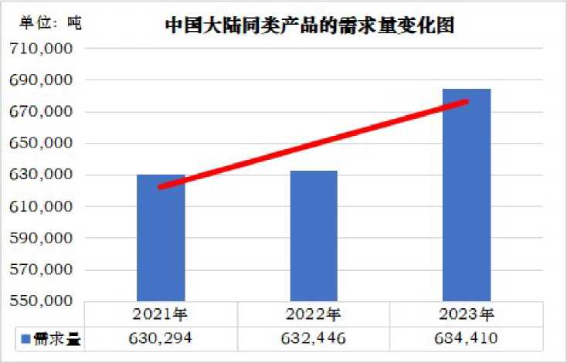

As shown in the above chart, during the application survey period, the demand for co-polymer formaldehyde in mainland China has continued to grow, from2021 to2023,63.03million tons, 63.24milliontons and 68.44million tonsrespectively,2022, 2023 comparedwiththe previous year, respectively increased by 0.34%and 8.22%, 2023 comparedto 2021cumulativegrowth of 8.59%.
Under the favorable market background of continuous demand growth, China's industrial similar products should have been well developed. However, as shown below, the application for a large number of low-priced imports of products in mainland China has become a clear impact and impact, and the industry in mainland China has suffered material damage once again.
  - Changes in production capacity, output and start rate of similar industrial products in mainland China
Changes in production capacity, output and start rate of similar products
Number of units:Thousands of tons.
During the period | Capacity of production | Production of | Rate of work | Increase and decrease the rate of work by a percentage point.
In 2021 | 38.20 | 35.08 | 91.83% | ₋
In 2022 | 38.80 | 35.85 | 92.41% | 0.58
In 2023 | 41.90 | 39.11 | 93.34% | 0.94
Note to:(1) Data from Annex XI:"Applicant financial data and statements";
(2) Start rate = production/production capacity.

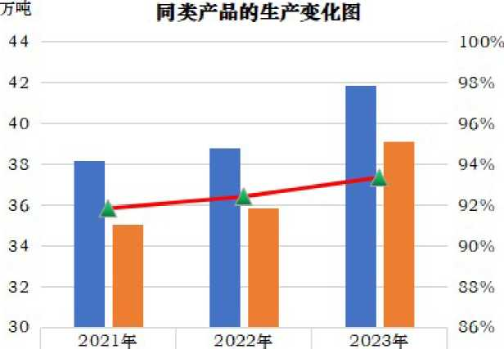
(I) production capacity 33.20 33.30 41.90
: The nose. 35.OS 35.S5 39.11
Rate of work91.33% 92.41% 93.34%

With mainland China's anti-dumping investigation and the adoption of anti-dumping measures on imports of South Korea, Malaysia and Thailand, the market competition environment has improved, coupled with the continuous growth trend of market demand, from2021to2023, China's mainland industrial similar products production capacity, output, start-up rate are trend.
However, as mentioned above, in order to circumvent the above anti-dumping measures, maintain or continue to seize the market share of mainland China, suppress the development of co-polymer formaldehyde in mainland China, Seranis Corporation, Baoli Plastics Corporation, Mitsubishi Vas Chemical Corporation and its affiliates have significantly increased the export of formaldehyde outside Korea, Thailand and Malaysia, the United States, Taiwan region and Japan to the mainland China market, a large number of low-priced dumping applications for investigation products.Affected by this adverse effect, the expansion of similar products in mainland China has not brought corresponding scale benefits and profits, on the contrary, since2023, the pre-tax profits and investment yields of similar products in mainland China have declined significantly since 2023.
The profitability has been greatly reduced.
3.3Changes in sales of similar products in mainland China industry
Changes in sales of similar products in mainland China industry
The Unit:Thousands of tons.
During the period | Number of internal sales | Magnitude of change
In 2021 | 34.17 | ₋
In 2022 | 33.75 | - 1.23 percent
In 2023 | 37.26 | 10.39%

Note to:The data are derived from Annex XI:"Applicant financial data and statements".
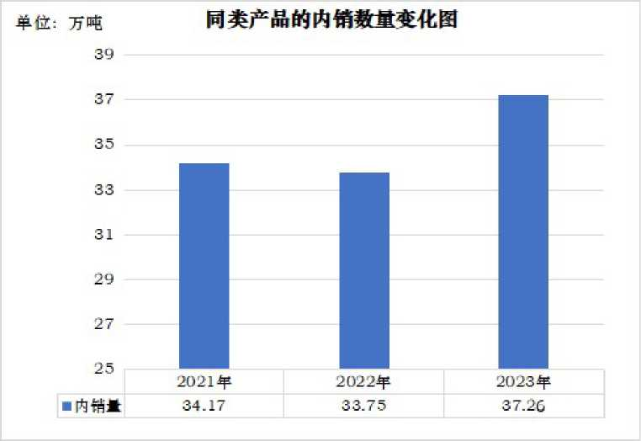

The above chart shows that with the expansion of the scale of the industry, since2021, the number of domestic sales of similar products in mainland China industry has also shown an overall growth trend.In 2022,2023compared with the previous year, the number of domestic sales of similar products in mainland China fell 1.23%,an increase of 10.39%, and an increase of9.03% in 2023 comparedto 2021.
During the application survey period, although the number of domestic sales of similar products in mainland China industry has generally increased trend, but the overall growth of similar product sales not only did not bring corresponding scale benefits and profits to the mainland China industry, on the contrary, due to the price of the application for survey products and suppression, mainland China industry can only maintain a certain sales and start-up level on the basis of sacrificing prices and profits, resulting in mainland China's industrial similar products unit gross profit, pre-tax profit, investment yield in2023.
3.4Changes in market share of similar products in mainland China
Changes in market share of similar products in mainland China
Number of units:Thousands of tons.
During the period | Internal sales and self-use | Amount of demand | Market share | Share increase by percentage point
In 2021 | 35.09 | 63.03 | 55.67% | ₋
In 2022 | 34.43 | 63.24 | 54.43% | -1.24
In 2023 | 37.59 | 68.44 | 54.92% | 0.49
Note to:(1) Internalsales and self-use=in-house sales+self-use, data sources can be found in Annex XI:"Applicant financial data and statements"; (2) Market share=internal sales plus self-use/demand.

Changes in market share of similar products
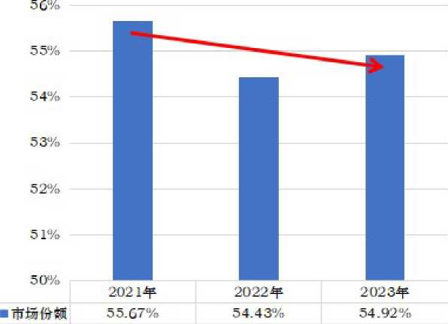

The above chart shows that due to the impact of a large number of products and low-priced dumping, the market share of similar products in mainland China industry has generally declined.In 2022,2023compared with the previous year, the market share of similar products in mainland China fell by 1.24 percentagepointsand an increase of 0.49 percentagepoints,2023compared with2021by a cumulative decrease of 0.75 percentagepoints, and the market share of application survey products increased by 1.03 percentagepointsin the same period.

3.5Changes in end-end inventory of similar products in mainland China industry

Changes in end-end inventory of similar products in mainland China
Number of units:Thousands of tons.
During the period | End of Period Stock | Magnitude of change
In 2021 | 0.87 | ₋
In 2022 | 1.05 | 20.17%
In 2023 | 0.53 | 49.67%

Note to:(1)The data are derived from Annex XI:"Applicant financial data and statements".
TheUnit:Thousands of tons. Chart of end-of-end inventory changes for similar products
1.20
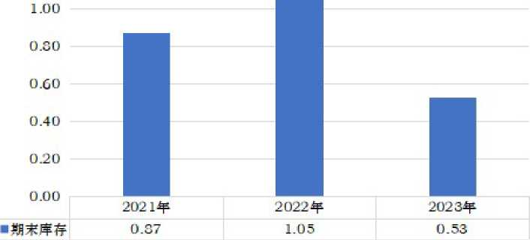

China's industrial similar products are implemented to sell the policy, the inventory is relatively small.The above chart shows that during the application for inspection period, the end inventory of similar products in mainland China industry has risen and dropped, and the overall trend is downward.In 2022 and2023 compared with the previous year, the end-of-term inventory of similar products in mainland China increasedby 20.17% anddecreased by 49.67%, respectively.
3.6Changes in prices of similar products in mainland China
Changes in domestic prices of similar products in mainland China
The Unit:Dollars / ton
During the period | The Inside Price | Magnitude of change
In 2021 | 14,149 | ₋
In 2022 | 15,133 | 6.95%
In 2023 | 10,756 | 28.92%
Note to:(1)Annex XI of the data sources:"Applicant financial data and statements";
(2) Internalsales price = internal revenue / amount of internal sales.

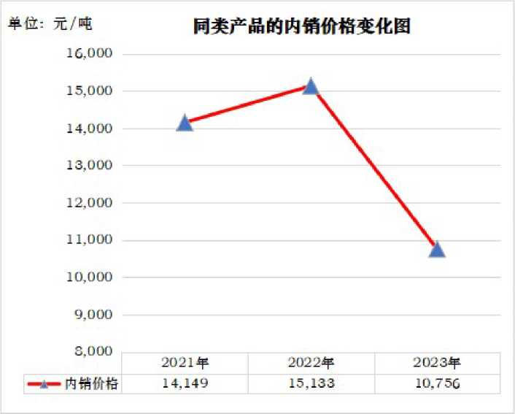

The above chart shows:In 2022, compared to2021, the price of domestic sales of similar products in mainland China industry increasedby 6.95%. However, due to the impact of a large number of products and low-priced dumping,2023compared with2022, the domestic prices of similar products in mainland China fell28.92%, 2023compared with2021fell by nearly24%.
As prices are significantly lowered and suppressed by the obvious price of the products applied for investigation, it has had a significant adverse impact on the domestic revenue, unit gross profit and efficiency of similar products in mainland China.

3.7Changes in sales revenue of similar products in mainland China

Changes in domestic sales revenue of similar products in mainland China
The Unit:Billions of dollars.
During the period | Internal Revenue | Magnitude of change
In 2021 | 48.35 | ₋
In 2022 | 51.07 | 5.64%
In 2023 | 40.08 | -21.53%
Note to:The data are derived from Annex XI:"Applicant financial data and statements".

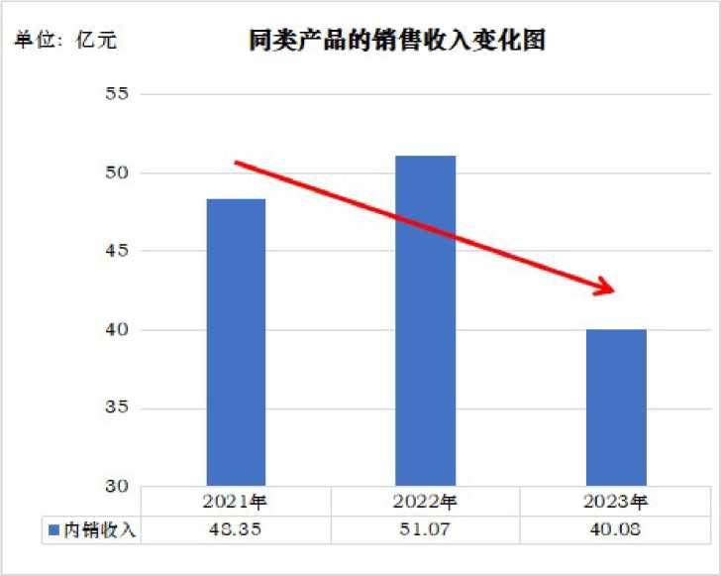

The above chart shows that similar to the trend of price changes,2022compared to2021, domestic revenue of similar products in mainland China increasedby 5.64%.However, due to the impact of a large number of products and low-priced dumping,2023compared with 2022, mainland China's industrial similar products domestic sales revenue fellby 21.53%, 2023compared to2021also decreased17.11%,and in turn has a significant adverse impact on the efficiency of similar products in mainland China.

3.8Changes in pre-tax profits of similar products in mainland China

Changes in pre-tax profits for similar products in mainland China
The Unit:Billions of dollars.
During the period | Pre-tax profits | Magnitude of change
In 2021 | 12.40 | ₋
In 2022 | 15.21 | 22.70%
In 2023 | 6.22 | -59.15%
Note to:The data are derived from Annex XI:"Applicant financial data and statements".

The Unit:Billions of dollars. Chart of changes in pre-tax profits for similar products
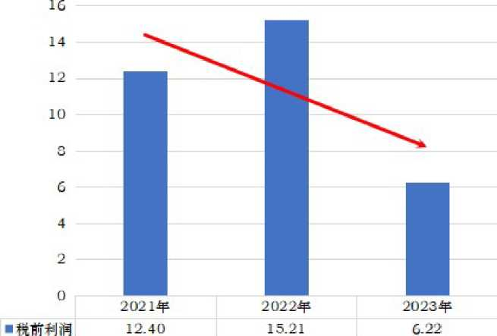

The above chart shows that similar to the trend of price and income,2022compared to2021, pre-tax profits of similar products in mainland China increasedby 22.70%.However, due to the impact of a large number of products and low-priced dumping,2023 compared with2022, the pre-tax profit of similar products in mainland China fell59.15%, 2023compared to2021 fell by nearly50%,and some enterprises were even in a loss state in2023.

3.9Changes in return on investment of similar products in mainland China

Changes in return on investment of similar products in mainland China
Number of units:Billions of dollars.
During the period | Average amount of investment | Pre-tax profits | Rate of return on investment | Increase and decrease.
In 2021 | 71.82 | 12.40 | 17.27% | ₋
In 2022 | 69.41 | 15.21 | 21.92% | 4.65
In 2023 | 68.26 | 6.22 | 9.11% | -12.81
Note to:(1)Data from Annex XI "Financial Data and Statements of Applicants";
(2) Rateof return on investment = pre-tax profit/average investment.

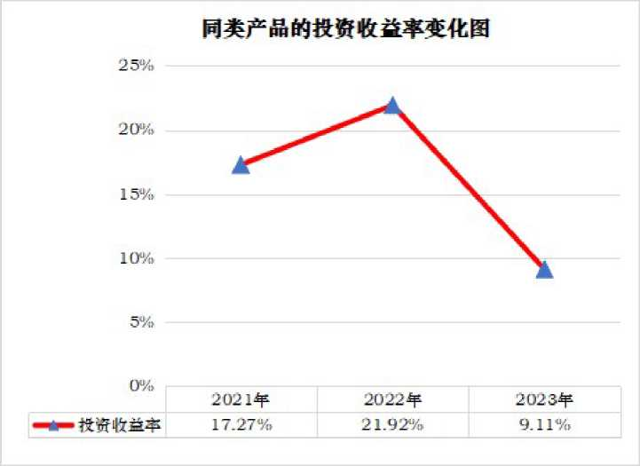

During the application investigation period, mainland China industry invested a lot of money in the production and construction of similar products, and the average annual investment of similar products was as highas7 billion yuan.
Consistent with the changesinpre-tax profits, investment returns on similar products in mainland China increased by4.65percentage points in2022compared to2021, but decreased by12.81percentage points in2023compared to 2022 and8.16percentage points compared to2021.The huge investment spent by mainland China's industry to build devices of the same kind cannot be effectively recycled, which will hinder the further development of the industry.
3.10Changes in net cash flows related to business activities of similar products in Mainland China
Changes in net cash flow of similar products in mainland China
The Unit:Billions of dollars.
During the period | Net cash flow | Magnitude of change
In 2021 | 22.80 | ₋
In 2022 | 20.50 | -10.09%
In 2023 | 10.21 | 50.19%
Note to:The data are derived fromAnnex XI:"Applicant financial data and statements".

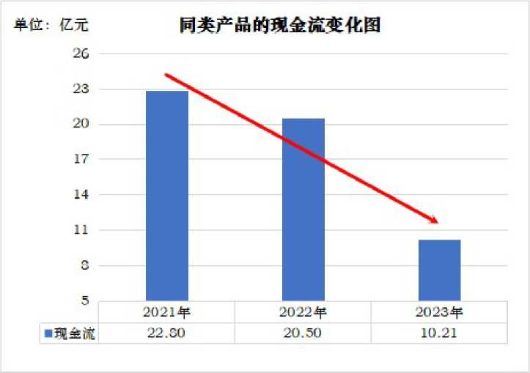

The above chart shows that during the application survey period, the net cash flow of similar products operating activities in mainland China industry has continued to decline.In 2022,2023 compared with theprevious year, the net cash flow of similar products in mainland China fellby 10.09% and50.19% respectively.

3.11Changes in wages and employment of similar products in mainland China

Changes in total wages, employment and per capita wages of similar products in mainland China
The Unit:The dollar;The people;The dollar/person.
During the period | Total salary | Number of employed | Magnitude of change | Salary per capita | Magnitude of change
In 2021 | 199,634,018 | 1,700 | ₋ | 117,410 | ₋
In 2022 | 240,185,728 | 1,952 | 14.80% | 123,046 | 4.80%
In 2023 | 235,552,059 | 1,932 | 1.02% | 121,921 | 0.91%
Note to:(1) Data from Annex XI:"Applicant financial data and statements"; (2) The per capita wage=total wage / number of employed persons.

The above chart shows that during the application survey period, the number of employment and per capita wages of similar products in mainland China industry has increased first and then decreased.In 2022,thenumber of employed persons and per capita wages increasedby 14.80%and4.80%respectively.In 2023, the numberof employed persons and per capita wages decreased by1.02%and0.91%, respectively.
3.12Changes in labor productivity of similar products in mainland China
Changes in labor productivity of similar products in mainland China
The Unit:Tons, people, tons/persons
During the period | Productivity of labour | Magnitude of change
In 2021 | 206.30 | ₋
In 2022 | 183.68 | -10.96%
In 2023 | 202.44 | 10.21%
Note to:(1) Data from Annex XI:"Applicant financial data and statements";
(2) Labour productivity=output/employment.

The above chart shows that during the period of the application survey, labor productivity of similar products in mainland China industry has risen first, and the overall trend is downward.In 2022 and2023 compared with theprevious year, labor productivity in mainland China's industrial equivalent products fell by 10.96 percent and increased by10.21%, respectively.It is down1.87%in2023 compared to2021.

Extent and type of damage
Through the above analysis and description, it can be seen that:In order to circumvent the anti-dumping measures of the co-polymer formaldehyde case in South Korea, Thailand and Malaysia, maintain or continue to seize the market share of mainland China, suppress the development of co-polymer formaldehyde in mainland China, Seranis Corporation, Baoli Plastics Corporation, Mitsubishi Vas Chemical Corporation and its affiliates have significantly increased the production and financial situation of South Korea, Thailand and Malaysia outside the EU, the United States, Taiwan region and Japan converging formaldehyde on the mainland, the export of formaldehyde to China, a large number of low-priced dumping applications to investigate products, and the production and financial situation of China's mainland industry similar products has caused obvious impact and impact on China's mainland real industry.
1, with mainland China on South Korea, Malaysia and Thailand import co-polymer formaldehyde investigation and the adoption of anti-dumping measures, the market competition environment has improved, coupled with the continuous growth of market demand, from2021to 2023, the production and sales of similar products in mainlandChinaindustry have generally increased trend.However, the overall growth of production and sales of similar products has not brought corresponding economies of scale and profits to mainland China's industries.
2, affected by a large number of applications for investigation products, low-priced dumping, the market share of similar products in mainland China has shown a downward trend,2022, 2023 comparedwiththe previous year decreased by 1.24percentagepoints and an increase of 0.49percentage points, 2023 and 2021comparedwiththe cumulative decline of 0.75percentagepoints, compared with the same period of application survey product market share increased by 1.03percentagepoints.
Duringthe period of the application investigation, the domestic price and unit gross profit of similar products in mainland China industry have declined overall.In 2022 compared to2021, the domestic price and unit gross profit of similar products in mainland China increasedby 6.95% and7.49%, respectively.However, due to the negative impact of the low and suppressed prices of the products applied for investigation,2023compared with2022, the domestic price of similar products in mainland China fell28.92%,and the unit gross profit decreased significantlyby 55.76%. In2023compared to2021, domestic prices and unit gross profit decreased by nearly24% and 52.45%, respectively.
Duringthe period of the application investigation, the domestic sales revenue of similar products in mainland China industry generally showed a downward trend.In 2022, domestic sales revenue increased by5.64%compared to 2021.However, affected by the large number and low-priced dumping of products applied for investigation, domestic sales revenue fell by21.53 percentcomparedto2022in 2023and17.11%in 2023 compared to2021.
Similarto the trend of price and income, the overall pre-tax profit of similar products in mainland China has declined.Pre-tax profits increasedby 22.70% in2022compared to2021,but2023was down59.15% from 2022,down nearly50% in2023compared to2021,and some businesses were even losing money in 2023.
Consistent withthechanges in pre-tax profits, investment returns on similar products in mainland China have also shown a downward trend. Investmentincome rose4.65percentage points in2022 compared to2021, but by12.81percentage points in2023compared to 2022,8.16percentage points lower than in2021.The huge investment spent by mainland China's industry for the construction of similar products can not be effectively recycled, which will hinder the further development of the industry.
Duringthe application survey period, the net cash flow of similar products in mainland China continued to decline, andin2022 and 2023 comparedwith the previous year, respectively, decreased by 10.09%and 50.19%.
Duringthe application survey period, the number of employment and per capita wages of similar products in mainland China industry showed a trend of increase and decline.Employment and per capita wages increased by14.80% and4.80%respectively in2022compared to 2021,but employment and per capita wages fell by1.02% and0.91%respectively in2023compared to 2022.
Duringthe period of the application survey, the labor productivity of similar products in mainland China industry fell first and then increased, and the overall trend was downward. In2022,2023decreased by 10.96percent andan increase of 10.21%, respectively, and 1.87 %in 2023compared to 2021.
Primafacie evidence shows that the dumping margin of the products applied for investigation to mainland China is on averagemore than 30%, and the dumping margin is huge.
In summary, the applicant believes that under the impact of the large number and low-priced dumping of the products applied for investigation:On the one hand, during the application survey period, although the production and sale of similar products in mainland China industry has shown an overall growth trend, the overall growth in production and sales of similar products has not brought corresponding scale benefits and profits to mainland China industry.Moreover, market share and labor productivity of similar products have generally declined.Employment and per capita wages also declined somewhat in2023compared to2022.
On the other hand, because the price is lowered and suppressed by the application survey products, it has become a serious negative impact on the efficiency of similar products.Throughout the application investigation period, the domestic price, unit gross profit, pre-tax profit and investment income of similar products in mainland China industry all showed a significant downward trend, and the net cash flow trend continued to decline.Moreover, the divisions were still losing money in2023.
In summary of the above situation, the applicant believes that the production, operation and financial situation of similar products in mainland China industry are deteriorating significantly.The large number and low-priced dumping of products applied for investigation are causing substantial damage to mainland China's industry.If anti-dumping measures are not taken in time, mainland China's industry will suffer more serious damage.
- Causal link between dumping and damage
- Application for investigation products cause substantial industrial damage in mainland China
With mainland China's anti-dumping investigation and the adoption of anti-dumping measures on imports of South Korea, Malaysia and Thailand, the market competition environment has improved, coupled with the continuous growth of market demand, from2021to2023, the production and sales of similar products in mainland China's industry have generally increased trend, and reversed the original investigation period of2012to2016, the situation of continued large losses in the first half of 2016.
However, in order to circumvent the anti-dumping measures of the co-polymer formaldehyde case in South Korea, Thailand and Malaysia, maintain or continue to seize the market share of mainland China, to suppress the development of co-polymer formaldehyde in mainland China, Seranis Corporation, Baoli Plastics Corporation, Mitsubishi Vas Chemical Corporation and its affiliates have significantly increased the export of formaldehyde outside South Korea, Thailand and Malaysia, the United States, Taiwan region and Japan to the mainland market for large, low-priced dumping of products.
Prima facie evidence shows a significant downward trend in the import price of products applied for survey products from the European Union, the United States, Taiwan and Japan, with a15.03%decline in2023compared to2022.Moreover, the four countries (regions) applied for the dumping margin of survey products to mainland China on average more than30%.

In fact, the low-cost strategy adopted by the application to investigate product manufacturers to suppress the intention and effect of the co-polymer formaldehyde industry in mainland China is obvious.The evidence shows that through the low price suppression strategy,2023compared with2021, the number of applications for survey products to the mainland of China has increased significantly by nearly16%,and the market share of mainland China is also maintained at an average level of about16%.
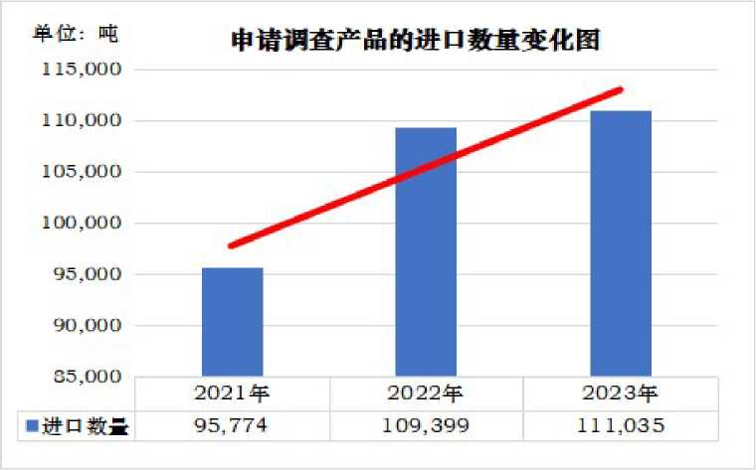
Chart of changes in the market share of mainland China.

13% of
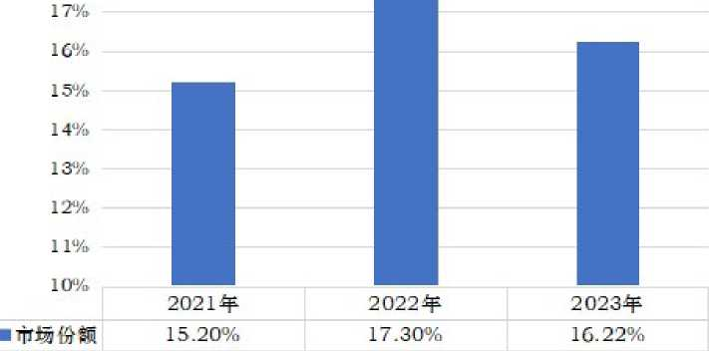

During the period of the application survey, the average market share of the application survey products in mainland China was about16%, if added to Sierra Nice's affiliate Korea Engineering Plastics Corporation and the Saudi State Methanol Corporation, a wholly owned subsidiary of Baoli Plastics Corporation Malaysia (Asia Pacific), Mitsubishi Was Chemical Corporation's holding subsidiary, Thai polyformaldehyde, limited companies converging the amount of formaldehyde in China, and the application to investigate the product manufacturer's two related companies in mainland China. in2023, the total market share of applied survey product manufacturers and their affiliates in mainland China has been as high as40%.
As mentioned above, the application for survey product manufacturers and their affiliates have a very important position in the global and mainland China co-polymer formaldehyde market, and its co-polymer formaldehyde sales price is the price benchmark in the global market, which has a major impact on the global and mainland China co-polymer formaldehyde price trend.Moreover, the application for survey product manufacturers and their affiliates co-selling polyformaldehyde in the mainland Chinese market has a brand advantage, and the price is an important factor affecting sales.
In the above context, the import price of the products applied for investigation has a major impact on the pricing of similar products in mainland China, and mainland China industry can only follow the application for survey product pricing.
The evidence shows that the import price of the products applied for investigation is the same as the trend of domestic prices of similar products in mainland China.In 2022, compared with2021, the import price of the products applied for investigation increasedby 11.19%,and the domestic prices of similar products in mainland China also increasedby 6.95%.However, in2023compared with2022, the import price of the products applied for survey decreased by 15.03%,mainland China industry can only be forced to follow the application for survey products to reduce prices, and the domestic price of similar products also fell28.92%.Moreover, judging from the mainstream and representative brands of application survey products and similar products in mainland China, the price changes in the mainland Chinese market, the prices of the two have a strong correlation.The import price of applications for survey products has significantly lowered the prices of similar products in mainland China industry.
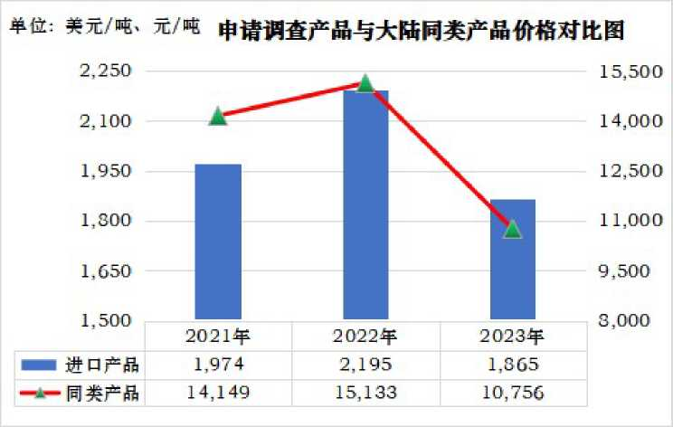

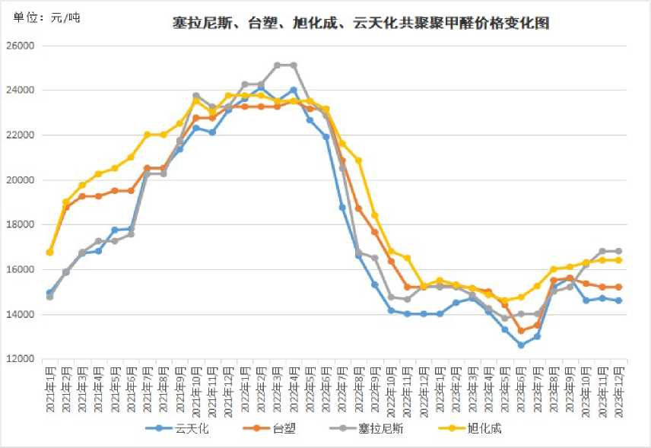

In addition, the application for survey products not only greatly reduced the price of similar products in mainland China industry, but also caused obvious price suppression of similar products in mainland China industry.The evidence shows that in2023, compared with2022, the gross profit per unit of similar products in mainland China fell by nearly56%,and a significant decrease of 52.45% compared to2021.
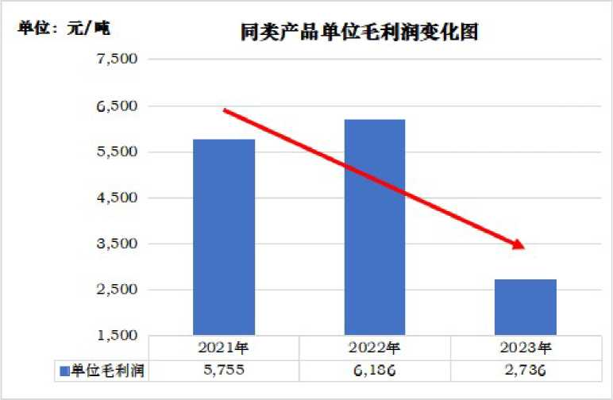

Under the huge impact of applying to investigate a large number of products and low-priced dumping, the production and operation and financial situation of similar products in mainland China have been significantly affected and affected, and the industry in mainland China has suffered material damage once again:
On the one hand, during the application survey period, although the production and sales of similar products in mainland China industry have generally shown an increasing trend, the overall growth in production and sales of similar products has not brought corresponding economies of scale and profits to the industry in mainland China.Moreover, the market share and labor productivity of similar products have generally declined.Employment and per capita wages also declined somewhat in2023compared to2022.
Changes in market share of similar products
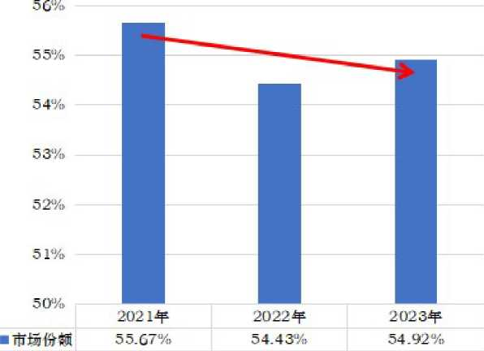

On the other hand, because the price is lowered and suppressed by the application survey products, it has become a serious negative impact on the efficiency of similar products.Throughout the application investigation period, the domestic price, unit gross profit, pre-tax profit and investment income of similar products in mainland China industry all showed a significant downward trend, and the net cash flow trend continued to decline.And some companies are still losing money in2023.
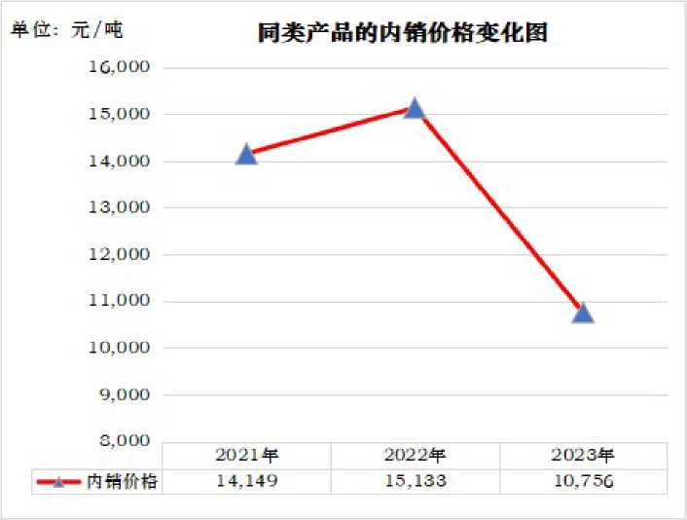

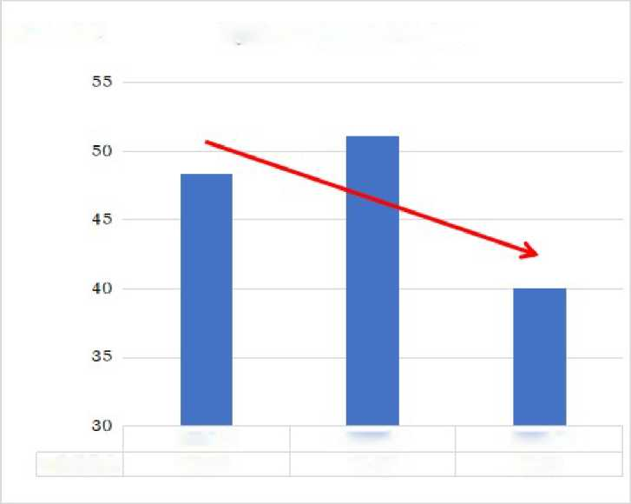
Changes in Sales Revenue of Similar Products
Unit: Billion dollars
In2021
2 02 2 years
Incorrectincome
4S.35
51.07
2D 23 years 40.0S
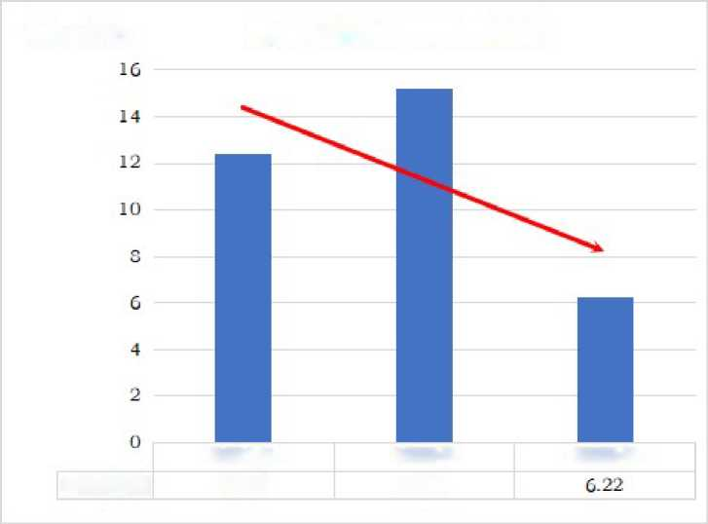
Unit: Billion dollars
Chart of changes in pre-tax profits for similar products
In2021
20 23 years
Pre-taxprofits
12.40
2022 and
15.21

Compared to:Billions of dollars. Cash Flow Changes in Similar Products
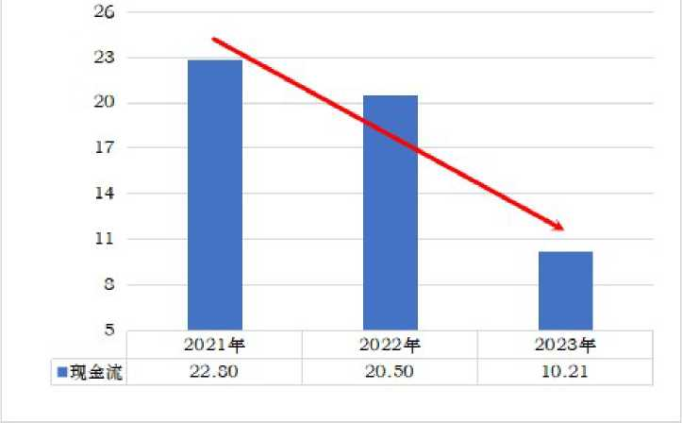

In summary of the above analysis, the applicant believes that the large number of applications for investigation products and low-priced dumping is the cause of substantial damage to the formaldehyde industry in mainland China, and there is a clear relationship between the large number of applications for investigation products, low-priced dumping and material damage suffered by similar products in mainland China.
- Analysis of other factors that may cause industrial damage in mainland China

Impactofimports from other countries and regions
Relevant evidence shows that the main source countries (regions) of imports of co-polymer formaldehyde in mainland China are in addition to the European Union of this application.
The alliance, the United States, Taiwan and Japan, mainly include South Korea, Thailand, Malaysia and Saudi Arabia.
From the point of view of import volume, the total import volume of other products during the application survey period showed an overall downward trend, down3.87%from2021in2023.However, the total number of imports applying for survey products has continued to rise, rising by nearly16%in2023compared to2021.Moreover, since2017, mainland China has imposed anti-dumping duties ranging from6.2% to 34.9% on imports originating from South Korea,Thailand and Malaysia.

Comparison of changes in the number of co-polymer formaldehyde imports
The Unit:Tons of
During the period | Total imports of non-application survey products | Total number of imports applied for survey products
In 2021 | 122,607 | 95,774
In 2022 | 104,865 | 109,399
In 2023 | 117,978 | 111,035
Note to:For data sources, please refer to annex V.

In summary, the applicant believes that the import co-polymer formaldehyde of other countries (regions) cannot deny the material damage caused by the application for investigation products to the mainland industry.

ImpactofChanges in Market Demand
During the application survey period, the demand for co-polymer formaldehyde in mainland China showed a sustained growth trend, from2021to2023was63.03million tons, 63.24milliontons and 68.44million tonsrespectively,2022, 2023 comparedwiththe previous year, respectively increased by 0.34%and 8.22%, 2023 comparedto 2021cumulativegrowth of 8.59%.Therefore, the applicant believes that the damage to the industry in mainland China is not caused by shrinking demand in the city.

ImpactofChanges in Consumption Mode
So far, there have been no policy changes in mainland China restricting the use of co-polymer formaldehyde products.And as mentioned above, since2021, the demand for co-polymer formaldehyde in mainland China has continued to grow steadily, so there has been no situation of shrinking demand for co-polymer formaldehyde due to changes in other alternative products.

Impactofchanges in exports
During the application investigation period, the export volume of the applicant's similar products accounted for only3% of the annual production,and the export price was higher than the domestic price.Therefore, the damage suffered by mainland China's industries is not due to exports.

Effectsof normal competition at home and abroad
As mentioned above, the application for survey products and products of the same kind in mainland China, the quality and quality of products, sales channels are basically the same.
Similarly, there are cross-cutting customer groups.In terms of production management, mainland Chinese production enterprises are also committed to the standardization and upgrading of management.
Therefore, similar products in mainland China have good market competition ability in terms of product quality or production and management.Moreover, mainland Chinese enterprises have obvious location advantages, and import products such as timeliness and convenience of delivery can not be replaced by favorable factors.If the application for investigation products to compete fairly with similar products in mainland China, mainland China's production industry has full local advantages and should not suffer such serious damage.

Commercial channelsofcirculation and the impact of trade policies
With the further deepening of reform and opening-up and the continuous improvement of the market economy system, the current mainland China co-polymer formaldehyde products fully implement the market-oriented price mechanism, production and operation is completely regulated by market laws.Similar products in mainland China industry in the same sales channels and applications for investigation products, in the field of commercial circulation there are no factors hindering the sale of similar products in mainland China or causing industrial damage in mainland China.
In addition, so far, mainland China has not promulgated other relevant policies restricting the trade behavior of the industry, and China's land industry has not been negatively affected in this regard.

Impactofforce majeure factors
During the period of the application for investigation in this case, the mainland China industry represented by the applicant did not have a natural disaster or other serious force majeure incident, and the production equipment of the same kind of product was operating normally and was not accidentally affected.
- Conclusion of
Based on the above analysis, the applicant believes that there is a causal relationship between the material damage suffered by the co-polymer formaldehyde industry in mainland China, and other factors are not the cause of substantial damage to the co-polymer formaldehyde industry in mainland China.
- Considerations of public interest
The applicant believes that the anti-dumping of the co-polymer formaldehyde industry is to correct the unfair trade competition of imported dumped products and eliminate the harmful effects of dumping caused by the co-polymer formaldehyde industry in mainland China.The purpose of anti-dumping measures is to restore and promote fair competition through unregulated low-priced dumping practices that undermine the normal market order in order to maintain and regulate the normal trade order.According to anti-dumping practices in countries and regions such as the European Union, when considering public interest issues, special attention should be paid to restoring distorted market order and protecting effective competition.
Due to the low-priced dumping of copoly formaldehyde products originating in the European Union, the United States, Taiwan and Japan in mainland China, it has seriously undermined the fair competition order of the mainland Chinese market and caused a serious impact on China's co-polymer formaldehyde industry. In this case, the adoption of anti-dumping measures will help restore this distorted competition order, which is conducive to safeguarding the safety of the co-polymer formaldehyde industry in mainland China and is in the public interest.
Due to the significant high crystallization properties of copolymeric formaldehyde, resulting in its metal-like hardness, strength and steel, it is known as "captured steel", "supersteel" or "race steel", in a wide range of temperature and humidity are good self-lubrication, good fatigue resistance, and elasticity, and have good chemical resistance.Moreover, co-polymer formaldehyde is low, relatively easy to process compared with metal products, and is lighter, and is widely used to replace zinc, brass, aluminum and steel and other metal products used in automobiles, electronic appliances, industrial machinery, sports equipment, medical appliances and other fields.
In the automotive field, co-polymer formaldehyde is widely used in seat belt buckles, interiors, filters, oil pumps, wipers, electrical assembly, bumper bumper bumper, line button, glass lift and other aspects, used to replace zinc, copper, aluminum and steel and other gold products, can significantly reduce the weight of the body, can effectively achieve energy saving and emission reduction, conducive to carbon peak, carbon neutrality and goal realization.
Therefore, in the "Twelfth Five-Year" Development Plan of the New Materials Industry, the "Guidelines for the Development of New Materials Industry" during the "13rd Five-Year Plan" and the Catalogue to Encourage Foreign Investment Industry(2019Edition), polyformdehyde is listed as a new material production industry to encourage development.In the current Catalogue of Encouraging Foreign Investment Industries(2022edition), polyformaldehyde is listed as an industry encouraging development in the central and western regions (Qinghai).Moreover, in the "14th Five-Year" new materials industry development plan in Anhui, Hubei Province and Tianjin, polyformdehyde is listed as the industries that encourage the development of these provinces and cities.
In addition, the upstream raw material of co-polymer formaldehyde is methanol, about70%of methanol in mainland China is coal-based methanol, polyformdehyde is an extension of the coal chemical industry chain, the development and growth of the coal formaldehyde industry industry in China to improve the added value of coal chemical industry chain related products, solve the upstream methanol and coal industry overcapacity, and promote the adjustment and optimization and upgrading of coal chemical industry structure is of great significance.
Co-polymer formaldehyde is also the only engineering plastic in engineering plastics that does not rely on crude oil and coal chemical products methanol as raw material, with a short process process, can be a large number of manufacturing engineering plastics, is an extremely important carbon-one chemical downstream product in the coal chemical product chain. Therefore, the development of polyformaldehyde industry is in line with the national conditions of mainland China's oil-rich coal.
In recent years, the continuous improvement of the production and quality of collegial formaldehyde products in mainland China has provided good raw material support for the downstream industry, which is conducive to the downstream industry to solve the situation of long-term dependence on imports of raw materials, and can promote downstream industries to reduce costs, enhance industrial competitiveness, and enhance the competitiveness of the above industries in domestic and foreign markets.
In addition, the normal development of the co-polymer formaldehyde industry is also conducive to the normal production and operation of downstream enterprises, reasonable prediction and control of raw material costs and reasonable planning for the future development scale, without being misled by the dumping price of imported products, even to the market chaos or abnormal fluctuations of raw materials, and affect the downstream industry's normal production and operation.The applicant believes that the co-polymer formaldehyde industry and the downstream industry is an interdependent relationship, and any party in the upstream and downstream industries suffers damage inevitably affects the interests of the other party, and even suffer damage.Only the upstream market is regulated, the price is maintained at a reasonable, stable and orderly level, upstream and downstream enterprises can co-exist, and downstream enterprises can ultimately benefit from a stable market.Therefore, the ultimate interests of co-polymer formaldehyde downstream consumer enterprises and the co-polymer formaldehyde industry are consistent, to carry out anti-dumping investigations and levy anti-dumping duties on dumping imported products, which is conducive to the common development of the polyformdehyde industry and the downstream industry, anti-dumping measures will play a role in protecting the ultimate interests of downstream consumer enterprises.
Moreover, in the long run, the implementation of anti-dumping measures will not materially affect the interests of downstream industries.Anti-dumping need is the dumping of imported products in a price-discriminatory manner, does not resist normal foreign trade, nor will it cause obstacles to legitimate and flat imports.The purpose of anti-dumping measures is to adjust the price of dumped imported products to a level playing field, and not to keep imported products out of the door.If the relevant anti-dumping measures are taken in the future, the application for investigation products can also be exported to mainland China at a fair and normal price level, and its legitimate import will not be restricted.
In summary, the applicant believes that it is in the public interest to carry out anti-dumping investigations and anti-dumping measures on imports originating in the European Union, the United States, Taiwan and Japan.
- Conclusions and requests
- Conclusion of
According to the above facts and reasons, the applicant believes that imports of formaldehyde products originating in the European Union, the United States, Taiwan and Japan have obvious dumping behavior in the mainland Chinese market, and this dumping behavior has caused substantial damage to the co-polymer formaldehyde industry in mainland China.
In such cases, timely and effective anti-dumping investigations and taking corresponding anti-dumping measures are conducive to restoring the distorted market competition order, protecting the legitimate rights and interests of the polyformaldehyde industry, and safeguarding the normal development of mainland China's industry, and thus protecting the safety and economic security of mainland China's industries.At the same time, conducting co-polymer formaldehyde anti-dumping investigations and taking anti-dumping measures will not materially affect the normal production and operation of the downstream industry, but also conducive to the stable and orderly development of the downstream industry.Therefore, it is in the public interest to carry out anti-dumping investigations and the acquisition of anti-dumping measures originating in the EU, the United States, Taiwan and Japan.
- Request for
In order to protect the legitimate rights and interests of the co-polymer formaldehyde industry in mainland China and the future development prospects, in accordance with the provisions of the Foreign Trade Law of the People's Republic of China and the Anti-Dumping Regulations of the People's Republic of China, the applicant requests the Ministry of Commerce of the People's Republic of China to conduct an anti-dumping investigation on co-polymer formaldehyde originating in the European Union, the United States, Taiwan and Japan and exported to mainland China, and based on the results of the investigation to the Customs Commission of the State Council to impose anti-dumping duties on aggregated formaldehyde products originating in the European Union, the United States, Taiwan and Japan and to mainland China.

Part II Request for Confidentiality
- Application for Confidentiality
In accordance with the provisions of Article22of the Anti-Dumping Regulations of the People's Republic of China, the applicant requests the confidential handling of the materials and annexes contained in this application, i.e., that this part of the material may be kept confidential in any way other than that provided for in the investigation authorities in this case and the anti-dumping regulations of the People's Republic of China, and the anti-dumping regulations of the People's Republic of China may be kept confidential in any way, prohibited from contacting, reviewing, retrieving or understanding in any way.
- Non-confidential summary
In order for the interested parties in this case to understand the comprehensive information of this application and the annex, the applicant hereby prepares the application and the public text of the annex, while the materials and information relating to the application's confidentiality are described or a non-confidential summary in the public text of the application and the annex.

III. Description of confidential treatment methods
For the relevant data and information relating to enterprise trade secrets in the body of the public text of this application, the applicant shall process confidentially in accordance with the following methods:For the confidential information involved in the text (the downstream customer name of the applicant's similar product), the original information is hidden in square brackets "[]", and the relevant non-confidential summary is provided in a text summary.

Part III List of Evidence and List
Annex I: Applicant's Business License and Power of Authorization
Annex II: Letter of assignment of counsel and certificate of practice of counsel
Annex III: Description of the production of co-polymer formaldehyde
Annex IV: Customs Import and Export Tax of the People's Republic of China,2021-2023Edition
Annex V: Mainland China co-polymer formaldehyde import and export statistics
Annex VI: Data sources and descriptions for sea freight and insurance premiums
Annex VII: Report of the World Bank Group on the costs of trade links in countries applying for investigation
Annex VIII: Price of methanol input cost of applying for survey products
Annex IX: Gross profit evidence material
Annex X: Golden Union statistics China mainland market co-polymer formaldehyde mainstream brand price
Annex XI: Applicant's financial data and statements

According to Annex III, "Note on the production of co-polymer formaldehyde", the company is a holding subsidiary of Powili Plastic Corporation of Japan.
According to the information provided by Ai Enterprise Investigation, the company is a wholly-owned subsidiary of Japan's Assange Corporation.
According to Annex III, Seranis Corporation of the United States is the parent company of Korea Engineering Plastics Corporation of Korea, with a shareholding ratio of50%;Japan Baoli Plastics Corporation is the controlling shareholder of Malaysia Poli Plastics (Asia Pacific), with a shareholding ratio of100%;Mitsubishi Vas Chemical Corporation of Japan is the controlling shareholder of Thailand polyformaldehyde Limited, with a shareholding ratio of70%;Celanese is the controlling shareholder ofthe European Union Celanese Production Germany GmbH& Co.KG, a100%shareholding;Japan Baoli Plastics Corporation is the controlling shareholder of Taiwan Bao Plastics Co., Ltd., with a shareholding ratio of75%.
According to the applicant's understanding, Seranis Corporation, Baoli Plastics Corporation, Mitsubishi Vas Chemical Corporation, Uxima Corporation and its affiliates have co-polymer formaldehyde production units in the world such as the United States, the European Union, South Korea, Thailand, Malaysia, Saudi Arabia, Taiwan, Japan and mainland China, the combined capacity of these installations account for more than60%of the total global co-polymer formaldehyde production capacity.
The anti-dumping duty rate applied by the Korean Engineering Plastics Corporation is30.0%, the tax rate of6.2%for Colonel Plastics Co., and30.4%for other Korean companies; The tax rate of polyformaldehyde Limited in Thailand is18.5%, while other Thai companies are34.9%;Malaysia Plastic (Asia Pacific) has a corporate tax rate of8.0%and other Malaysian companies at9.5%.
The company is a wholly owned subsidiary of Seranis, USA.
Japan Baoli Plastics Corporation is the controlling shareholder of Taiwan Bao Plastics Co., Ltd., with a shareholding ratio of75%.

